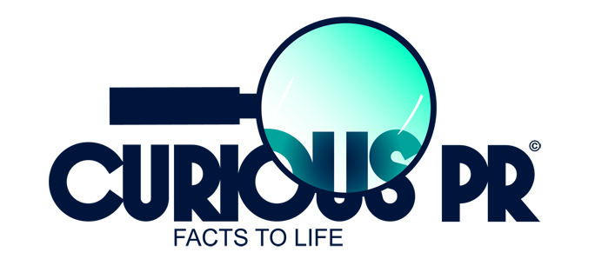

Q&A Document

What has changed? (Introducing Colosseum Dental UK Ltd
From 1st March 2018, Southern Dental is to be known as Colosseum Dental UK Ltd, a change that takes place roughly a year after being purchased by Zurich-based Colosseum Dental Group. With 80 practices in England, this new ownership means it is the only UK dental chain to be part of a pan-European network.

Colosseum Dental Group is the fastest-growing network of dental practices on the continent, with over 200 clinics, having recently added Finnish and Italian practices to its portfolio. Its ambition is to be Europe’s leading dental provider within five years.

Colosseum Dental Group UK currently employs 255 dentists, 64 hygienists, 260 nurses, 58 practice managers and 150 receptionists across 19 counties, from Devon to Nottinghamshire.

What do the changes mean for patients?
Colosseum Dental UK Ltd treats over half a million patients. The needs of all its NHS and private patients will continue to be met, despite the changed name of the company. Furthermore, the majority of its 80 practices will undergo an extensive refurbishment programme, introducing a new look and feel to waiting rooms and upgrading of treatment areas and clinical facilities.

Local practices will still be providing dental care at the heart of the community, with the added benefits that come with being part of a thriving international group. The practices will also retain the name by which they’ve been known - in many cases, for many years.

When it comes to equipment and supplies, Colosseum Dental Group has relationships with top suppliers in the field, enabling it to procure the best products at the best prices, a benefit that will ultimately be passed on to patients.

The Group wants to ensure that patients benefit from fast-improving digital technologies. It recently made the decision to make intraoral scanners available for ALL patients. Additionally, it is creating more specialist referral centres, such as those already in existence at Kettering and Kingston. These centres offer treatments such as orthodontics, periodontics and implantology, in addition to a range of facial aesthetic options. Treatments will be carried out using state-of-the-art equipment such as 3D CBCT scanners to provide high resolution 3D images that can be digitalised and used as a planning tool for precise guided surgery.

Patients requiring more complex or specialist treatments will be given access to an Advanced Treatment Coordinator providing advice and support on treatment options.

What do these changes mean for staff?
Career development: as part of a large European network, staff will benefit from improved training opportunities and the potential to develop their career within a dynamic, fast growing European group. The company will continue to offer flexible ways of working and encourages take-up of its mentorship opportunities. It continues to offer training bursaries for dentists who are applying for Masters and Postgraduate programmes.

What do the changes mean for recruitment?
The group is actively recruiting, drawing on its European links to tackle the nationwide dentist shortage. Dentists looking to further their career in the UK can receive support, not just in terms of NHS compliance, but also with the practicalities involved in moving to a new country, such as finding a place to live.

What does being part of Colosseum Dental Group UK mean for the practices?

Refreshed clinics:
A rolling programme of refurbishments within the existing 80 practices is underway, and scheduled to be complete by the end of 2018. With the backing of Colosseum Dental Group, the management team is committed to investing in equipment to ensure that patients continue to receive excellent care.

Best practice and peer support:
Already, the practices are benefitting from improved training and expertise. As part of a network of colleagues and specialists who consult regularly within the UK and across borders, Colosseum staff will gain access to industry expertise and broader opportunities to develop their careers. At a clinical level, Colosseum Dental Group is developing templates and guidelines to be used across all territories, and is exploring ways of measuring outcomes to generate performance / outcome data that can be shared across the European network to better inform decisions surrounding treatment planning and care.

In addition, the company will hold its first Annual Conference in April 2018 where industry leaders drawn from a range of backgrounds, including the business of dentistry and legal aspects, plus specialist treatment, will speak on innovation and best practice within their niche, helping to inform and inspire clinical Colosseum’s and non-clinical teams.

ABOUT COLOSSEUM DENTAL UK LIMITED
Colosseum Dental UK Limited is the third largest chain of dental practices in the UK, with 80 clinics spanning 19 counties. The company supplies high quality general dental care, as well as specialist services for NHS and private patients. It has more 900 employees and Associates, including over 250 dental professionals, serving more than 500,000 patients. Its mission is to be the ‘best in class’ dental group in the South of England by providing modern, quality dentistry services for the benefit of patients, dentists, employees, shareholders and striving for continuous growth and excellence. www.colosseumdental.co.uk

MEDIA ENQUIRIES

For all enquiries, including interview requests or hi-res images, please contact Hannah Kapff or Francesca Crutchfield at Curious PR Hannah@CuriousPR.com | Francesca@CuriousPR.com
T +44 (0)20 3397 9111|M +44 (0)7747 794306| Insta CuriousPR |Tw @Curious_PR |www.CuriousPR.com

