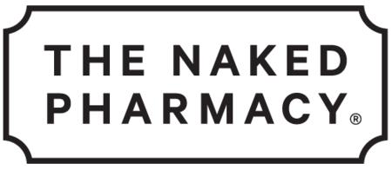

Media Case Study
Saffrosun – For psychological balance and fatigue
https://www.thenakedpharmacy.com/collections/nervous-system/products/saffrosun

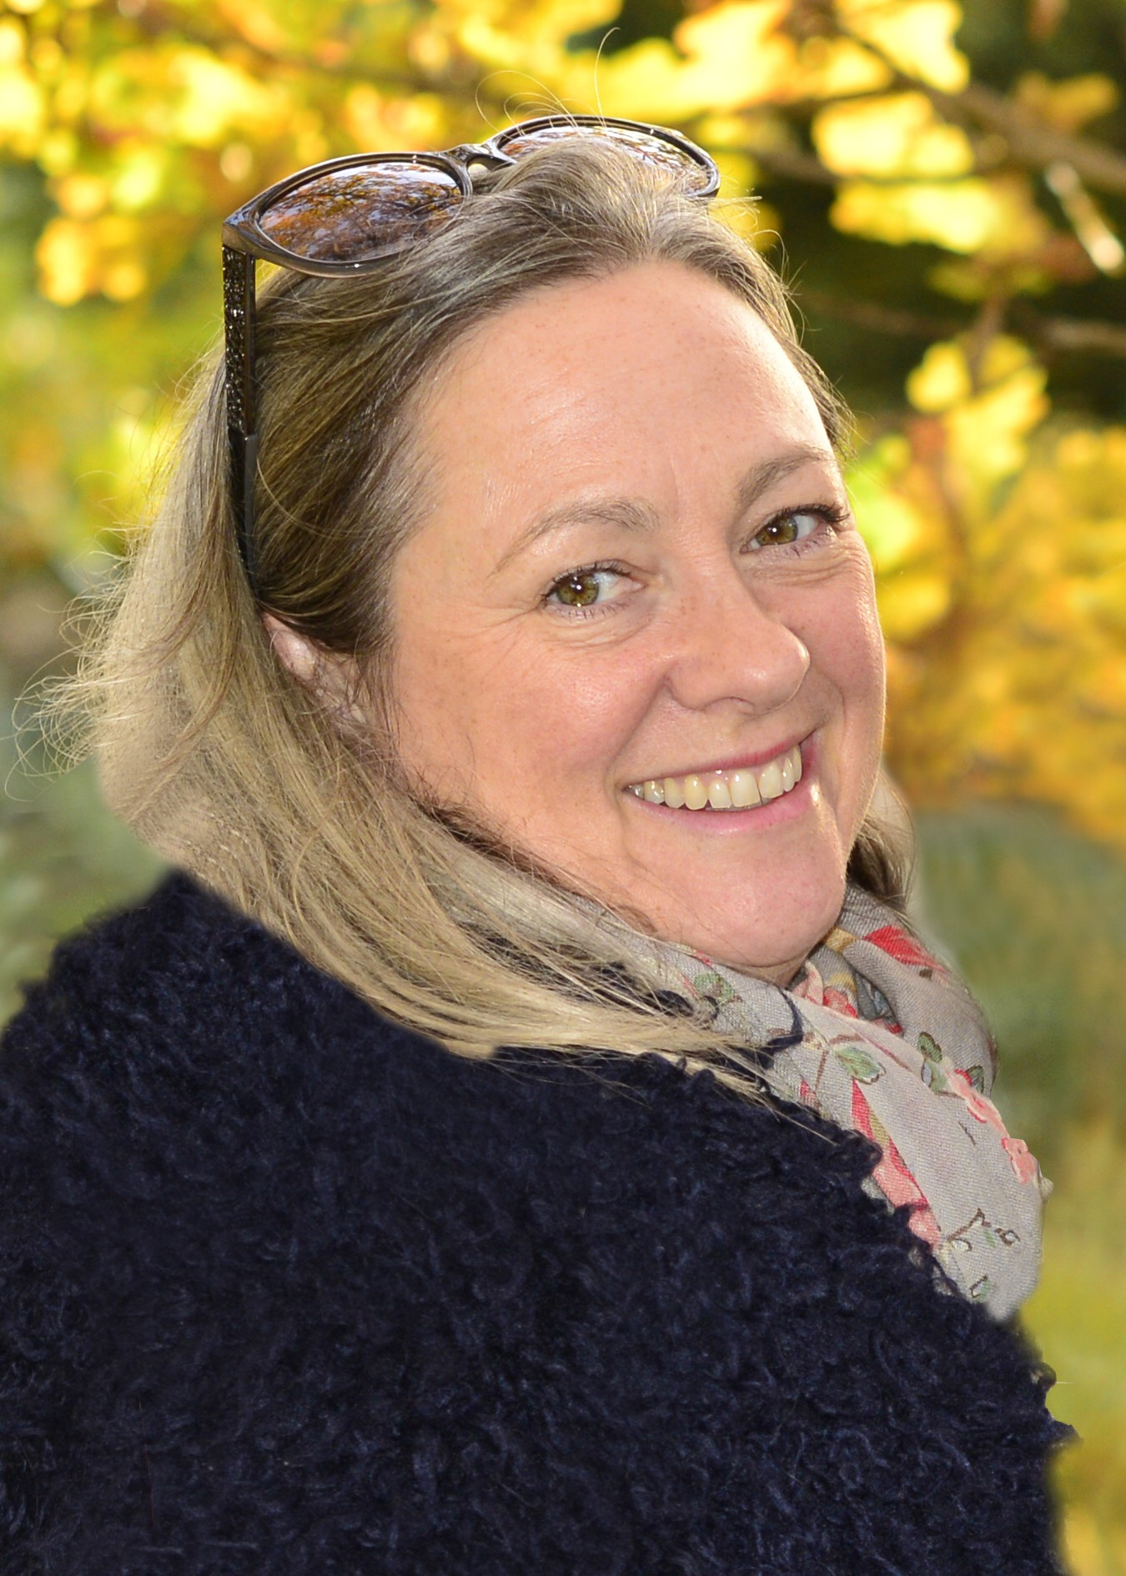
Eleanor Pool
Dip Hyp CS
Ad Dip PsyC

I started taking Saffrosun 8 months ago and feel like a different person. I lead a very busy life with demands on my time and emotional energy and as I approach 50 was beginning to feel physically and mentally exhausted. I have never been susceptible to mood swings form PMT but suddenly found myself increasingly irritable and snappy. In all honesty, I was experiencing bouts of rage (a new experience) over matters that simply didn't warrant the level of anger I felt. I was also experiencing forgetfulness and brain fog which didn't make any sense to me and only served to increase irritability. I had tried a brief spell of HRT prescribed by the GP but the side effects of bloating and weight gain far outweighed the short-lived benefits which only lasted a few weeks before the erratic emotional responses returned. Furthermore, taking medication to deal with a natural process didn't sit right with me.
I started taking saffron after a friend suggested it. For 6 weeks, I took it alongside my HRT tablets before dropping them completely and relying solely on the Saffrosun.
I experienced an almost immediate sense of stability in my thinking, the brain fog lifted and the irritability vanished. My emotional capacity to deal with the demands of my life felt invigorated.
Within 3 weeks of stopping the HRT my weight dropped by 12lb and remained fairly stable ever since.
I am so happy to be able to journey through this hormonal process supported by a wholly natural product.
Thank you.

Media Case Study
Saffrosun – For psychological balance and fatigue
https://www.thenakedpharmacy.com/collections/nervous-system/products/saffrosun

Nick Richardson, 43
Surrey

I suffered a viral attack on my heart in May 2014 called Myocarditis. After a week in hospital, many drugs, an MRI and more, I was told that the virus had not damaged the heart but I was left with inflammation around the muscle of the heart. I was prescribed to take 4 ibuprofen tablets 3 times a day, 2 paracetamols 3 times a day and gout tablet. I was advised to continue to take the tablets until I felt well enough to stop taking them. The cardiologist gave me the impression I would recover quickly.

The viral attack leaves inflammation around the heart, which makes you unable to take part in any sports activities. It reduces you to a very slow pace of walking and gives you a constant aching pain in the chest. It often gives you a burning sensation as if stoked through the chest and out of your back. The lack of physical activity and ability is quite shocking.

In September 2014, after a follow-up appointment, there was still no improvement to my health and I was dependant on over the counter tablets and the gout tablet to relieve the constant aches and pains.

The cardiologist was surprised I was not any better and after a second MRI the results concluded that I had made little improvement and recommended doubling the recommended daily dosage! He suggested a 10x dosage of Anadin 3 times a day as he was at a loss as what else he could suggest to improve my situation. I only managed to take two of these tablets as it increased the pain tenfold. So I just continued with the pervious tablets.

Those who have suffered the same viral infection have commented on Myocarditis forums that they too have suffered for a much longer period than was initially suggested by doctors with the after math of the inflammation left by the viral attack.

By February 2016 I decided that I should not continue to take the high dosage of ibuprofen and that I should try to reduce the amount I was taking. This presented a problem as I was now dependant on them, which I soon found out. Out of the 12 ibuprofen a day I was taking, I tried to drop just one tablet a day per week. I would get so low from this and it would create what some would call a ‘cotton wool head’, struggling to think properly and have negative thoughts. I had become addicted to the ibuprofen. It would take about 2 weeks for me to feel normal again and I began to dread dropping another tablet, as I knew what I would have to go through.

I decided to see a new Cardiologist for a second opinion. This doctor was fair and completely honest about my situation. Like the Myocarditis forums, where I had read other sufferers’ accounts, he said that unfortunately there is no known treatment and it will be something I would have to live with. He said that he seen other people with in a similar situation; it my get better or it may not, or it may come back as it can lay dormant. Unfortunately, I was stuck with it.

The only thing he could recommend was 1 of 6 other tablets to try, ranging from cheapest to the most expensive of basic forms of antidepressant tablets. The first one I tried made my face all puffy and sent me to ga ga land and I stopped taking those within a couple of weeks. The second tablet I tried disagreed with me again and gave me a mouth full of ulcers and cold sores. Again, I had to stop them.

It was at this point that I decided to try alternative therapies. I saw an acupuncturist and she said that my body was full of inflammation. She recommended a Paleo diet to reduce the inflammation. She also put me in touch with Kevin from The Naked Pharmacy.

When I contacted Kevin at The Naked Pharmacy, he could not have been more helpful. We had a half hour telephone consultation where I was able to tell him all about my case. It was then that he recommended that I take:
- Aged black garlic - for cardiovascular and immune protection
- Natruflex (turmeric and black pepper) – for muscles and joints
- Saffrosun (includes saffron and other supplements) – for psychological balance and fatigue
Kevin recommended I take his supplements for two weeks and then gradually start to reduce all the other tablets. After the two week period, I was able to stop all over the counter and prescription drugs in one go with no withdrawal side effects. This really did prove to me that the supplements worked.

A year later I have now been able to take up jogging again and can do most types of physical exercise. I very rarely have pain (only when I forget to take The Naked Pharmacy tablets!). My mental health has greatly improved and on the whole, I feel back to normal. What is so wonderful about The Naked Pharmacy products is that they work and they have no side effects. These tablets really have changed my life.

I have also recommended Saffrosun to friends who now also swear by them. In one case, her partner had bi-polar tendencies but refused to go on any medication. He is now taking Saffrosun and she has really noticed a difference in him. The Naked Pharmacy products really do work.

Media Case Study
Saffrosun – For psychological balance and fatigue
https://www.thenakedpharmacy.com/collections/nervous-system/products/saffrosun
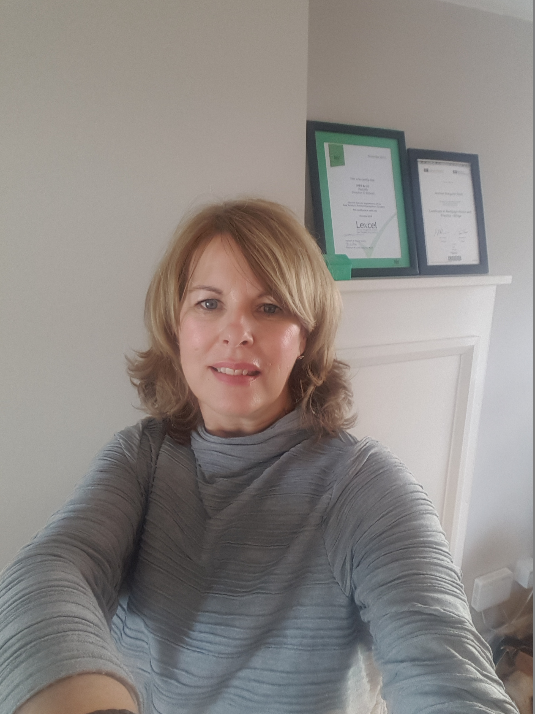
Andrea Scott, 54
Mortgage Consultant
I would just like to thank you for sending Saffrosun to me and how quickly my online order came through from your company. After 4 days of taking Saffrosun and having a low mood prior to taking it, I have seen for myself the positive changes in my mood and I have a new buoyancy whilst tackling the day to day pressure in life. This is really helping me and increased my energy levels.

Media Case Study
Saffrosun – For psychological balance and fatigue
https://www.thenakedpharmacy.com/collections/nervous-system/products/saffrosun

J.O., Surrey
Over the past two years I have been suffering from depression and severe agoraphobia. I have only been able to leave my flat for essential shopping and returned home as soon as I could. Agoraphobia is one continuous panic attack, and is an irrational fear of open spaces, people and crowds. It is terribly debilitating and has led to my putting on a considerable amount of weight due to lack of any movement or exercise, which normally I love, and my usual confidence disappeared. I could not even pick up the phone to chat with my friends and family and even my own mother.
Then, about 8 weeks ago, a close friend of mine contacted me about this nutritional supplement Saffrosun, based on a high quality extract of saffron. They asked me to trial this supplement for a two week period and after only 6 days, I jumped on the bus to visit my mum and spent the whole afternoon with her, and felt so bubbly and hyper it was just incredible. This new attitude then left me and I went back in to my shell again. But 3 weeks later and since then, I have been going out virtually everyday on my bike and loving the outdoors and the sunshine by the river and the beautiful scenery. I have been on long cycles, have visited my mother on several occasions and enjoyed spending quality time with her, and also enjoyed going out to see friends again with music and dancing. My confidence level has increased at least 60 - 70 %. My friend who recommended Saffrosun to me has also had good feedback from other clients with problems with mood and anxiety.
There is a way to go yet, but the change in my level of determination to beat this has altered dramatically and I now find myself planning the next day’s activities instead of just sitting at home doing absolutely nothing.
This product has no side effects and so is very reasonably priced and I have only taken it for a short period of time. It is also not addictive, being a nutritional supplement. I must stress I am not completely cured but my life has changed dramatically in such a short period of time.

Media Case Study
Saffrosun – For psychological balance and fatigue
https://www.thenakedpharmacy.com/collections/nervous-system/products/saffrosun
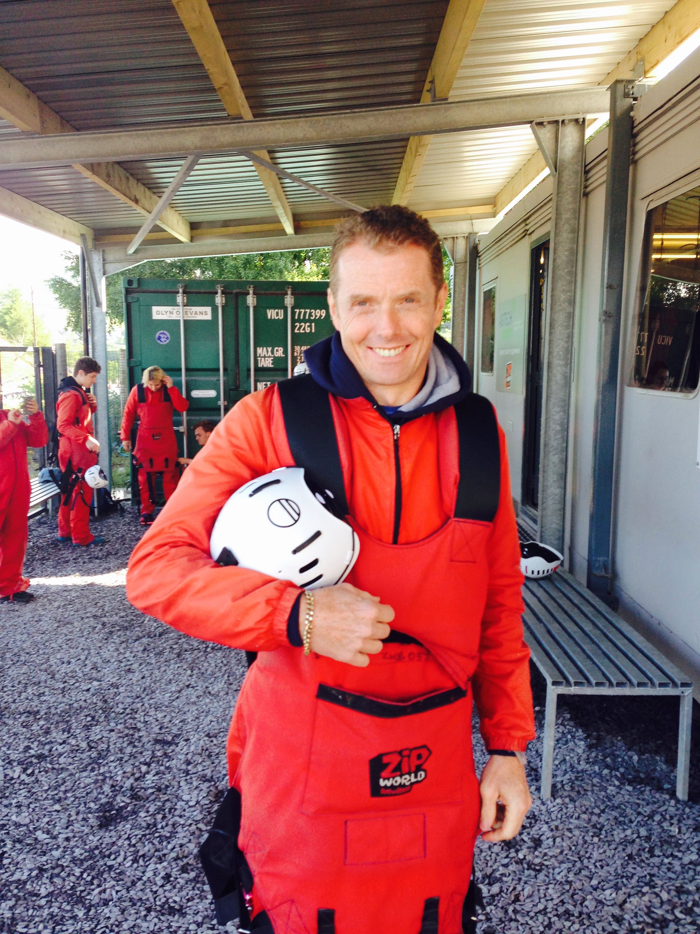
Mark Hyatt
Crawley

Poor quality and lack of sleep has been a consistent problem of mine, especially during stressful times or when I am under high pressure at work. In the past this would leave me feeling tired and irritable during the daytime and affect the following night’s sleep and so on. I heard about a new saffron based supplement called Saffrosun, made by The Naked Pharmacy and have been taking 2 capsules a day for about 7 months for my general well-being and to improve both the quality and amount of sleep.

I have found that the Saffrosun has really helped improve my sleep patterns. I have loads more energy and I definitely feel that the product has given me a happy and contented feeling that I hadn't experienced before. I am now able to reduce the intake to just one capsule a day and wouldn't be without it. I think this is an excellent product and the fact that it is based on saffron, a natural spice, is a bonus too.

Media Case Study
Saffrosun – For psychological balance and fatigue
https://www.thenakedpharmacy.com/collections/nervous-system/products/saffrosun
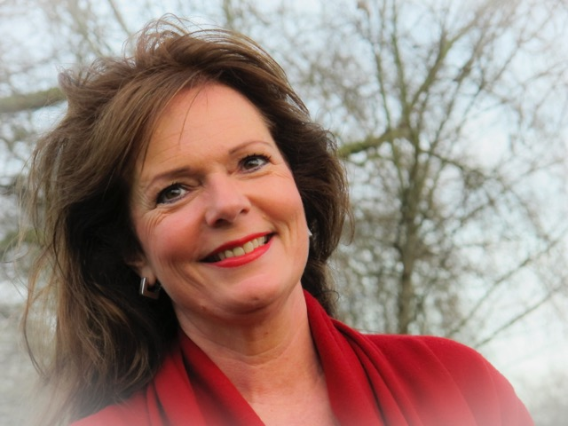
Meron Shapland, 58
CBT Therapist
Sussex

On and off I have suffered with depression for a number of years. On occasions, I have resorted to using prescription drugs. I have never felt happy doing this as I would prefer the natural route. Over the years I have had some help with the natural alternatives available. But I would continue to wake in the early hours of the morning feeling as if life wasn’t worth living.
It was suggested to me that I should try Saffrosun by The Naked Pharmacy. After a week, I noticed that I know longer had the dark thoughts every morning, they have literally disappeared and are no longer part of my life. I had begun to lack confidence also and that too has dropped away.

I have been taking Saffrosun for two months & feel blessed to have been introduced to this product. I have been reintroduced to my old happy confident self which is wonderful.

Media Case Study
Saffrosun – For psychological balance and fatigue
https://www.thenakedpharmacy.com/collections/nervous-system/products/saffrosun

M, London
London

Many people at some point in their life will probably have a spell of this and then there are some people like myself who have dealt with this since an early age.
My depression started from the age of 12 years old and I was referred to the doctors and put on a prescription of antidepressants called Fluoxetine. I became withdrawn from people with a high feeling of anxiety and panic attacks - it was like depression came as a package, with these extras to go with it and I couldn’t cope, so I turned to substance abuse and many times over the years have attempted to take my life. Over the years, I have been put on different medications, such as Citalopram (anything up to 60mg), Diazepam, Propranolol etc, but still I have found myself in the same position of struggling to stay on them and over the past 4 years I stopped with them all. I rarely take anything as I don’t like taking medication but my life has been a struggle still. The past two years I’ve been signed off as sick and have been unable to socialise and have found myself becoming a recluse. This year a family member called me and asked me if I wanted to try these new superfood capsules. At first, I was very sceptical about it but I thought that it couldn’t hurt, I had nothing to lose.
He sent me one month’s worth of Saffrosun, and immediately I googled all the ingredients and was pleasantly surprised to read all the information about the saffron plant and became very excited to start taken them. I only stuck to them for about 3 weeks but I did notice a change, but yet again I stopped taking them. For the past 2 months I have been on these capsules again and certain things have been life changing.
I take 2 capsules a day and have been taking them constantly every day for nearly 2 months. With this I have noticed significant changes. My anxiety, which has crippled my life, has decreased, as has my depression. My tiredness has faded, and within the past 2 weeks I have even been able to give up alcohol! I’ve been alcohol dependant for 15 years and have tried many times to give it up, but have been unsuccessful. Well, as of today I haven’t touched any alcohol in two weeks and 1 day. Now don’t get me wrong I’m not saying these are a cure for that but what I did notice is that due to feeling better in ways like my anxiety and low moods, I had the willpower to choose to now stay off it! I have now signed myself off the sick and am currently looking for a part time job. I’m turning up to all my appointments and am now organized on a daily basis. These might sound like things that people do on a day to day basis but if you struggle with crippling depression and social anxiety this is a big deal.
My concentration levels have increased and something I have noticed is my eye contact with people. I’ve always struggled with eye contact when talking to people and now I find myself concentrating on what they are saying and making eye contact with them as they talk. I’m socialising better and am up every morning at a good time, even if I don’t have much to do. I’ve not sat in bed all day for over three weeks now due to crushing depression, which is a first.
These are early days but in such a short period of time I have made some very big changes and am finding myself integrating back into the world again, one day at a time, but most of all I’m excited about it and I look forward to what the new year will bring with a clearer mind and a much more positive outlook thanks to the Saffrosun.

Media Case Study
Saffrosun For Children Testimonial
https://www.thenakedpharmacy.com/collections/babycare/products/saffrosun-for-children

Aragon Athaide-Leivers
Surrey

Symptoms:
- Restless and hyperactive, with sleep problems for over 5 years

Medication:
- Not taking any, and does not want to

Since taking Saffrosun:
- Low restlessness
- Little problem with sleep
- Good general wellbeing
- 1-2 capsules a day

Media Case Study
Saffrosun – For psychological balance and fatigue
https://www.thenakedpharmacy.com/collections/nervous-system/products/saffrosun

Mrs L

When I started using Saffrosun, I was highly anxious, tense, stressed and had disrupted sleep because of weaning myself off chronic medication related to my mental health. Although I am good at keeping my mental health in check through lifestyle habits, I knew I needed just a little bit of extra help to regain my calm and balance again. So when I was sent a free sample of Saffrosun by Kevin’s wife, Abigail, I had nothing to lose by trying it. After only a week I could feel a difference in the fact that I was more focused, had more positive energy and was able to fall asleep better and consequently get out of bed quicker. After my 14 day free trial was over, I thought that perhaps the Saffrosun had nothing to do with the changes and that in fact it was my lifestyle habits. I was proved wrong after I stopped taking it and it was almost in a matter of days that I could feel that same old original lethargy and anxiety return. I am convinced 100% that this remedy has supported me through some very tough transition times and that without it, I would not be as on track as I am. I highly recommend this for anybody who is serious about supporting their mental wellbeing in a proactive way that is not only natural, but also quite frankly revolutionary!

ABOUT THE NAKED PHARMACY
To learn more, visit www.TheNakedPharmacy.com | Facebook | Instagram | Twitter

MEDIA ENQUIRIES
For all enquiries, including interview requests, case studies, hi-res images + video content, contact Curious PR: Hannah Kapff Hannah@CuriousPR.com T +44 (0)20 3397 9111 M +44 (0)7747 794306 Insta CuriousPR Tw @Curious_PR Web www.CuriousPR.com

