

**Santa has parked his sleigh in Oxford Street, London, for the public to ride!**

Under the cloak of night-time, with a lot of elvish secrecy, Santa’s iconic red sleigh arrived at John Lewis, Oxford Street, last week, to kick off the festive season. For the first time ever, visitors to the London store are invited to go for a free ride in the sleigh owned by the celebrated resident of the North Pole and star of the famous Portable North Pole video messages.

Launched on the 23rd September, visitors to the Oxford Street store can experience the magic of Portable North Pole at the 3rd floor Christmas Shop, where Santa’s sleigh has been parked for the season, as patrons take the reindeer on a training flight with magical technology. A video of their adventurous flight from the North Pole to London will be sent to the visitor’s email address as a keepsake, and to share with loved ones.

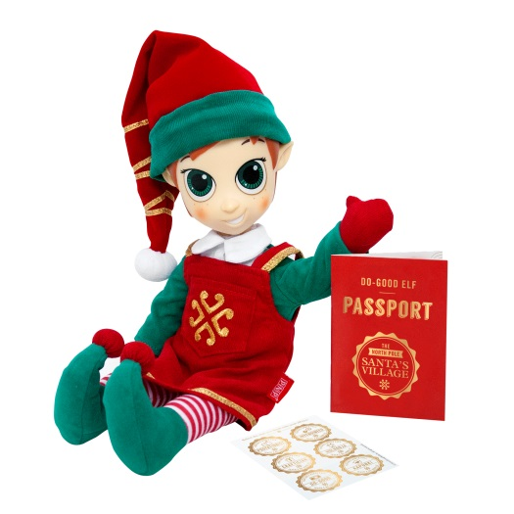The sleigh is parked in celebration of the brand new Portable North Pole Toys and Gifts Collection (PortableNorthPole.com/Collection). The range includes new traditions, toys, games and gifts to help modern families bring the magic into the lead up to Christmas. New this year, the PNP collection is exclusive to John Lewis and includes gifts such as a Good Deeds Game, the official Santa Letter, the Twenty-Four Sleeps ‘til Santa book, a Santa Letter Kit and a Do-Good Elf.

The elves fine-tuned the story of the Do-Good Elf in collaboration with a leading Child Development expert to help families create a new positive tradition during December. Children are encouraged to model positive behaviour and show their adopted baby elf the difference between naughty and nice. There is also an Elf Case to carry your Christmas companion, an Elf Door (turn on the light to connect your home to Santa’s Village) and Santa’s Magic Key to help Father Christmas visit this Christmas Eve. Other items include Häni, Santa’s Littlest Reindeer, an Elf Hat and Elf Slippers.

In keeping with PNP’s rich personalisation tradition, every toy and gift in the collection links to an exclusive personalised video message from Santa, which is the magic at the heart of the Portable North Pole. The packaging of each gift contains a special code that unlocks an exclusive video from Santa explaining the Christmas story behind the enchanted gift. By visiting the PNP website (PortableNorthPole.com/collection), the gift-giver can include details about the recipient to help Santa craft a customised video message filled with personal touches.

**For more information about the Portable North Pole and the brand toy and gift collection contact** [**Lauren@evolution-pr.co.uk**](mailto:Lauren@evolution-pr.co.uk) **or call 01327 227010.**

**About UGroupMedia**

**UGroupMedia Inc. (UGM) are a family entertainment company and the proud producers on PNP-Portable North Pole. Established in 2008 and based in Montreal, Canada, the UGM team use technology to make magical, personalised digital experiences delivered through the PNP website, mobile apps, television series, products, in-store experiences and more.**