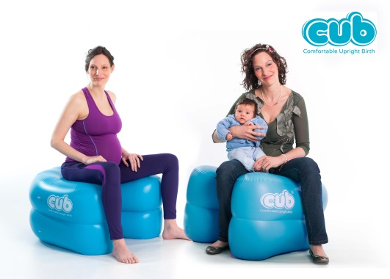

Hospitals adopt an easy solution to decrease the rising rates of Caesarean sections in the UK

If you have recently been to any antenatal classes, hospital tours or even been online you may have noticed the latest product designed for use during birth; if not you soon will because the Comfortable Upright Birth (CUB) Support is now used in more than half of all maternity hospitals and birth centres in the UK as well as in countries from Iceland to Australia, the USA and China.
Scottish company Birthsparks Ltd. are the creators and global distributors of the award winning CUB that is now the most widely used, innovative product to reach the healthcare maternity market in recent years. They are delighted to announce that the CUB will be available for mothers who want to ensure they have access to a CUB during pregnancy to help them have the safer, healthier birth that they want.
So what is it?
The CUB is a cross between a birth ball and a birth stool; designed by a midwife to provide comfortable support for mothers who want to maximise their chance of a natural, active birth by using a variety of upright positions.
What does the CUB do?
For Maternity services:
A cost study by the NHS Institute has calculated that a potential £65.5 million could be saved by reducing the national caesarean rate by 4%; this equates to a saving of £510,000 per trust per year. As health service budgets are decreased motivation to save money wherever possible increases; particularly when there are also proven clinical benefits for mothers. The UK Caesarean rate is currently in the region of 25% with rates as high as 41% in some areas! So clearly using a simple, inexpensive product to help decrease these rates is a great idea in terms of health and economic benefits.
For Mothers: The CUB allows the mother to adopt and maintain positions that are not only the most comfortable but physically the most helpful for her and her baby during labour, making giving birth easier, faster and most importantly, safer. Upright positions during birth (sitting, kneeling, squatting, and all fours) have been the topic of much research in recent years, and the results of the research are dramatically in favour. Being upright during labour and birth can increase the space within the mother’s pelvis by up to 30%, allowing more room for the baby to be born, labour contractions can be more effective making labour shorter, babies are 54% less likely to become distressed and mothers are a whopping 29% less likely to need an emergency caesarean section! For mothers who are choosing to give birth naturally having their own CUB will ensure they can use these really beneficial positions whenever they want.

In light the extensive research in favour of Upright Birthing, the CUB was launched at the International Confederation of Midwives Triennial Congress in June 2014, to instant success. It’s now being added to maternity units across the globe as women strive for an easier, safer and more comfortable way to bring their babies into the world. To date the CUB has been sold into over 40 different countries worldwide and is rapidly becoming the new, must have item to support mothers through childbirth. Feedback from Mothers, Midwives and Obstetricians has been incredible and sales are growing daily, not only in the UK but from many countries worldwide.

The CUB can be used by mothers at home in late pregnancy to encourage baby to adopt an ideal position for birth as well as throughout labour as a comfortable support, either to sit on, rest on or lean over as well as to give birth to the baby on if they so choose. The CUB is suitable for use in maternity hospitals, birth centres or at homebirths and it is available for mothers to buy for themselves as well as healthcare facilities who wish to offer a more natural approach to giving birth to their mothers.

QUOTES ON THE CUB

From Doctors and Midwives
Brilliant product! A great innovation for childbirth, a simple idea but it but really works More comfy that a birth ball Our midwives LOVE our CUBs A really useful addition for the birth room A lovely waterbirth in Norway last night-the CUB helped get her there through a long labor I was amazed at how relaxed the mother was We all want to do everything we can to help mothers have an easier, safer birth and the CUB really helps us do this, it’s a great product!
Comments from Mothers Was fantastic to use, every mother should have a CUB The midwives were amazed by how comfortable I looked The only place I wanted to be during my massive 24 hour labour was on my CUB! It made it easier to push sitting on the CUB I loved how it moved with me, I felt totally relaxed It was great for moving and rotating which made contractions more manageable It is the perfect shape to cuddle, squeeze and hold on to. I used it in late pregnancy to relax on and I am sure it helped me to have a quicker birth
Please visit our website here:

http://www.cub-support.com/
Watch the CUB animation here:
http://www.cub-support.com/watch-the-cub-animation/

CUB photo bank:
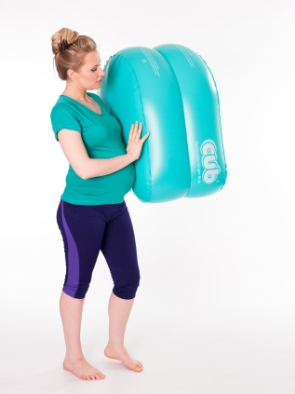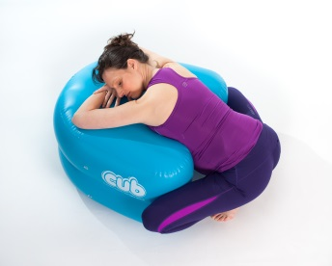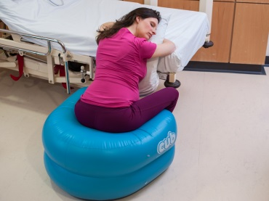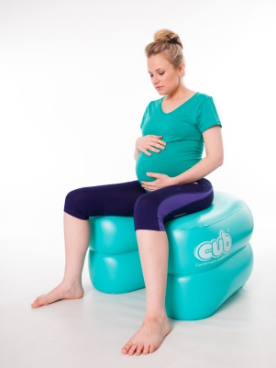
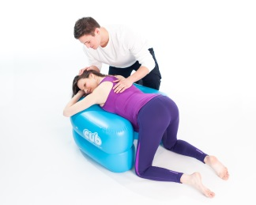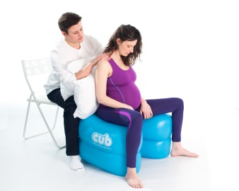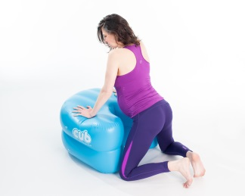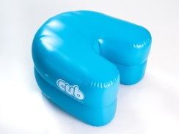
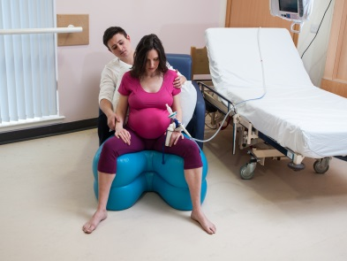
©Birthsparks Ltd. All photos can be presented in high resolution upon request.
Contacts:  Cass McNamara, CEO  M: +44 (0) 7960090756  E: Cass@birthsparks.com  Tanya Sigorska, Marketing Executive  +44 (0) 1563 851404  E: tanya@birthsparks.com | Birthsparks Ltd  Unit B2  Olympic Bussiness Park  Drybridge Rd  Dundonald  KA2 9BE UK | Web: www.cub-support.com  Phone: +44 (0) 1563 851404  Email: office@CUB-support.com  F: facebook.com/CUBsupport  T: @CUBCass

