

Press Release
Issy-les-Moulineaux, April 21, 2026

“Transformations, Skills, and Learning” Barometer 2026
To mark its 100th anniversary,
the Cegos Group analyses global changes in the world of work
and their impact on the future of training

68% of HR directors rank AI and automation as the top transformations
that will impact skills within their organisations over the next two years

Only 32% of employees have already received training in AI
through a community of practice or training offered by their organisation

In 2026, the Cegos Group will celebrate its 100th anniversary. A century of commitment and innovation dedicated to skills development, organisational transformation, and the professional world, in France, Europe, and around the globe.

In this special edition of its international barometer “Transformations, Skills, and Learning,” the global leader in professional training highlights the trends and tensions currently affecting organisations: the rise of artificial intelligence, the rapid evolution of professions, the need to continuously adapt skills, and increased pressure to provide the right training at the right time.

Cegos also chose to survey Human Resources professionals and employees themselves on how they envision work and training by 2035.
In this context marked by accelerating technological and societal change, training emerges as both a lever and a challenge at the heart of issues related to foresight, agility, and collective performance.

Conducted in December 2025 and January 2026 across 11 countries in Europe, Asia, and Latin America, the survey brings together the perspectives of more than 5,500 employees and nearly 500 HR and training decision-makers, identifying commonalities, differences in perception, and the dynamics at play on an international scale.

Methodology:
Online survey conducted in December 2025 and January 2026 in 11 countries:
- Europe: France, Germany, Italy, Portugal, Spain, United Kingdom
- Asia: China, Singapore
- Latin America: Brazil, Mexico, Chile
The survey was conducted among 5,524 employees (including 502 in France) and 498 HR Directors/Managers or Training Directors/Managers (including 60 in France), within private companies or public organisations with more than 50 employees.

MAJOR TRENDS
Workplace transformations: AI and upskilling at the forefront of concerns
- 31% of employees surveyed fear that their job will disappear.
- 74% expect changes to the nature of their work.
- 68% of HR directors surveyed rank AI and automation as the top transformations that will impact skills within their organisations over the next two years, far ahead of new ways of working, demographics, and the green transition.
- According to HR directors, 23% of current jobs are at risk of skills obsolescence within three years.
- 65% of HR directors prioritise upskilling over recruitment.
- 57% are promoting internal mobility to other roles.

By 2035
- Employees and HR anticipate a world of work that is above all more tech-centric (data, algorithms, AI…), more mobile, and more agile (remote work, flexible schedules…).
- Employees are confident in their ability to adapt to this environment (average score of 7/10)
- Employees and HR believe that the top priority will be to develop distinctive human skills in the face of AI (23% of employees / 21% of HR), followed by ensuring employees’ employability in the face of these transformations… far ahead of supporting the ecological transition (for only 9% of employees / 8% of HR).

Skills: continuous and accelerated training to ensure competitiveness and employability
- 91% of HR professionals state that skills development is strategic for their organisation
- 78% of employees share this belief
- One in four employees already feels that their skills are becoming obsolete or expects them to do so (10% already; 16% soon)
- 77% of HR professionals believe their organisation is agile enough to meet expressed training needs
- But 41% of employees feel that training comes too late to meet their needs.

Generative AI: widespread adoption… that hasn’t fully taken hold in the professional sphere
- 79% of employees use generative AI for personal purposes but only 64% use it for professional purposes.
- 84% of HR professionals say their organisation is capable of integrating the technological impacts on job roles within three years, but only 28% have formalised and shared AI usage guidelines with employees.
- Only 32% of employees have already received AI training through a community of practice or a training program offered by their organisation.

Learning & Development: prioritising the integration of training into the workflow… and AI as a lever for personalising learning paths
- 55% of training sessions are still delivered in person
- 64% of HR professionals favour on-the-job training and 50% favour co-development.
- 68% of HR professionals strongly support integrating training into daily work.
- 63% of organisations have already used generative AI for training or are currently doing so.
- 57% of them use AI to personalise learning paths or are currently doing so (+20 percentage points in 3 years)

I – An overview of the major transformations underway and their impact on work and skills

For HR, AI and technology are by far the leading drivers of transformations that will impact skills over the next two years

For HR directors, the next two years will be marked primarily by the impact of technological transformations on employee skills.
Among the major challenges cited, artificial intelligence and automation are by far the top concerns (for 68% of HR professionals globally) far ahead of the evolution of information systems and cybersecurity (41% globally) and new forms of work organisation such as hybrid work or freelancing… (33% globally).

When it comes to skills, technological challenges now dominate the Human Resources agenda, surpassing managerial changes (28% of HR professionals globally), demographic shifts (26% globally), and societal expectations (23% globally).
As for the green transition, it remains relegated to last place, cited by only 15% of respondents.

The rapid adoption of generative AI in society has also shifted priorities within companies: organisational transformation is now primarily viewed through the lens of AI integration, securing digital environments, and adapting processes and business functions to technological disruptions.

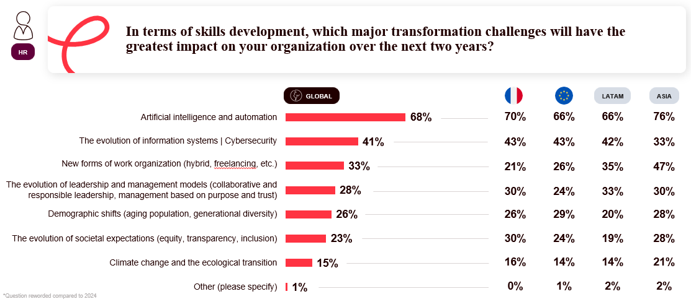

Grégory Gallic, Director of Custom Projects at Cegos, analyses:
“Generative AI has burst into our lives so rapidly and on such a massive scale that it is not just one topic among many, but very often the lens through which HR leaders now view the future of their organisations. Corporate strategy —and, by extension, training policies—are now often structured around anticipating technological impacts. This focus is entirely legitimate, but it must not overshadow the new managerial, societal, and environmental expectations that employees are voicing and that companies must also address.”

3 out of 4 employees anticipate their job evolving rather than disappearing

Less than a third of employees believe that current transformations (technological, climate-related, societal, etc.) could cause their job to disappear (31% overall). This figure remains stable compared to 2024.
In contrast, 3 out of 4 employees anticipate a change in their work (74% overall).
Employees therefore seem to be embracing a mindset of continuous development and learning.
It should be noted, however, that concern is significantly higher in Asia (China and Singapore), where 44% of employees fear their jobs will disappear.

HR professionals estimate that within three years, one in four jobs is at risk of skills obsolescence

For HR directors, the multiple transformations underway represent above all a challenge in terms of adaptation and skill retention.
According to them, on average within their organisations, 13% of jobs are at risk of skills obsolescence within one year, and 23% within three years, or nearly one in four jobs in the medium term.
This latter figure is up 4 percentage points compared to 2024, confirming the acceleration of business and professional transformations.

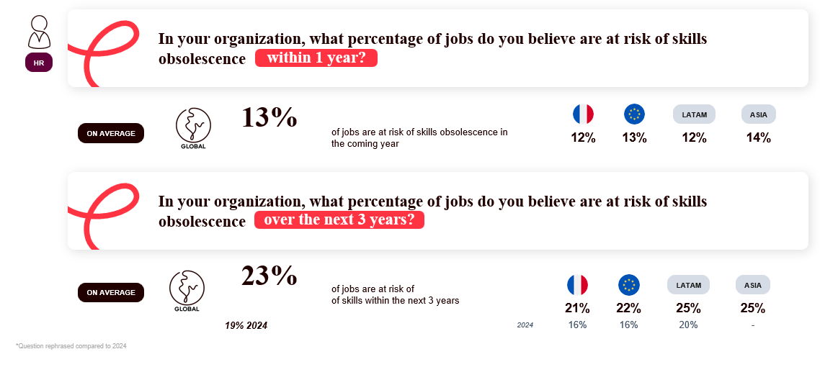

Grégory Gallic, Director of Custom Projects at Cegos, explains:
“Employees are realistic, but not overly anxious. They don’t overwhelmingly fear the disappearance of their jobs, but they are fully aware that they will have to work differently. HR directors, for their part, anticipate that nearly one in four jobs could see its skills become obsolete within three years. The challenge is less about coping with a sudden disruption than about preventing the gradual, structural erosion of skills. They now need to implement training and reskilling programs that are faster, more targeted, and ongoing.”

To cope with multiple transformations, HR directors prioritise upskilling over recruitment

To address changes in job roles and professional practices, HR directors are prioritising the upskilling of current employees: 65% overall report supporting their teams to develop skills in their current roles.

Internal mobility and career transitions are also on the rise, with 57% of HR directors developing their employees’ skills to transition into other roles, compared to 47% in 2024.

Conversely, the recruitment of new profiles is declining significantly, to 46% overall compared to 59% in 2024.

Grégory Gallic, Director of Custom Projects at Cegos, continues:

“Companies seem to have learned from previous waves of transformation: hiring isn’t enough; it’s often complex and doesn’t necessarily provide a long-term solution. The sustainable solution lies in the continuous development of skills internally, with a focus on anticipation and mobility. The strategic lever is to engage everyone in a culture of lifelong learning—that is, identifying and then developing their talents.”
Looking Ahead to 2035: Employees and HR Envision a More Technological, Flexible, and Agile World of Work…
Employees and HR share a largely convergent vision of the world of work in 2035.
They envision it first and foremost as more technology-centric (56% overall for both employees and HR), then more flexible and mobile (44% of employees, 50% of HR), and more agile and adaptable (40% of employees, 41% of HR).
The more societal or collective dimensions—sustainability (30% of employees, 29% of HR professionals) and collective intelligence (26% of employees, 27% of HR professionals)—remain in the background.
This projection echoes the predominance of technological changes noted earlier.
The most significant gap between HR and employees concerns flexibility (+6 points on the HR side), reflecting stronger expectations from management regarding work organisation.
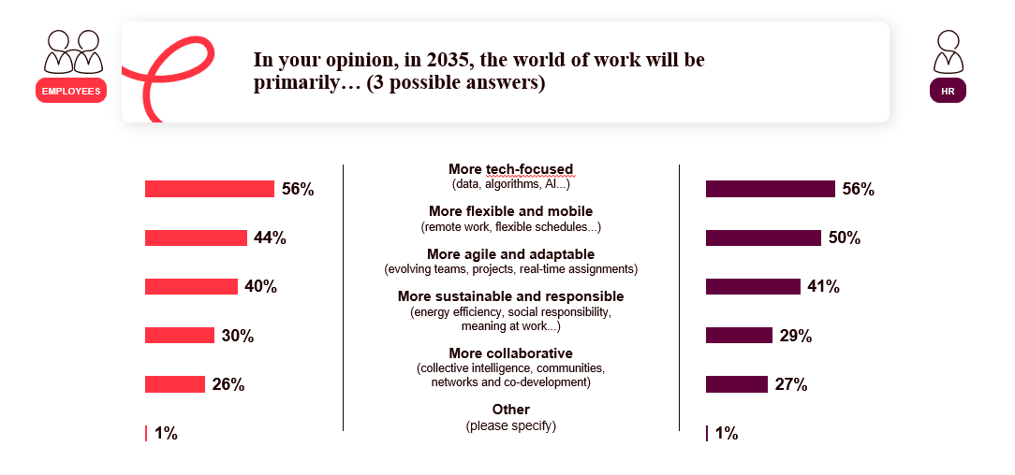

… and continue their search for meaning at work
Looking ahead to an increasingly technological and flexible world of work, 67% of employees say they are seeking more meaning in their work than they did three years ago. This expectation is particularly pronounced in Asia (76%) and Latin America (83%).
Rapid and constant change does not, therefore, diminish the demand for meaning; on the contrary, it seems to reinforce it.
Grégory Gallic, Custom Project Director at Cegos, explains:
“In an environment perceived as faster and more digital, the sense of purpose, contribution, and alignment with personal values becomes an even more essential benchmark. The quest for meaning at work continues, and is even intensifying. The training function must therefore integrate the concepts of performance, employability, and purpose to give meaning to each individual’s contribution within the context of the company’s overall strategy.”

Facing the world of work in 2035, strong individual confidence…
When asked about their ability to adapt to the world of work in 2035, employees and HR professionals express a high and aligned level of confidence: 7.1/10 for employees and 7.2/10 for HR professionals.
Despite the diversity and speed of the changes underway, employees feel ready for the professional world to come. This individual confidence can be viewed in the context of HR strategies that focus on upskilling, which likely contribute to reinforcing this sense of adaptability.
… and more measured in the organisation’s ability to adapt
When asked about their organisation’s ability to adapt to the world of work in 2035, employees and HR professionals offer a slightly more nuanced assessment, rating it at 6.9/10. This moderate gap reflects a slight discrepancy: individuals perceive their organisation as slightly less agile than they perceive themselves to be. The challenge appears to be less individual than collective.
Grégory Gallic, Custom Project Director at Cegos, adds:
“Everyone believes they can adapt to the future world of work. Confidence is more fragile when it comes to the entire organisation’s ability to adapt. Employees are likely questioning its speed of adaptation, its strategic alignment, and the resources it mobilises to support change. This is precisely where the L&D function is expected to step in: to bridge the gap between individual commitment and potential and the collective capacity to adapt and learn, effectively and at the right pace.”

II - Skills: The Strategic Challenge of Time to Competency, Training “Just in Time” to Balance Competitiveness and Employability

A consensus on the strategic nature of skills and an increasingly transparent training offering within companies
Skills development is now widely recognised as a strategic lever. Nearly all HR professionals surveyed (91% overall) indicate that it is a strategic issue within their organisation, a view corroborated by 78% of employees.
When asked about their level of awareness regarding training offerings within their organisation, employees are generally positive, with an average rating of 6.9/10 overall, up from 2024 (6.8). Nearly 7 out of 10 employees give a rating between 7 and 10.

This trend positions training as a central element of the social contract between the company and its employees. It is no longer perceived as a peripheral or one-off initiative, but as a key mechanism for adaptation, securing career paths, and maintaining employability.

Nearly 7 out of 10 HR professionals are moving toward a more competency-driven organisation
Since skills development is central, organisations are increasingly adopting a "skills-based" approach. As a result, 68% of HR professionals globally report that they manage career paths, mobility, and projects based more on skills than on job titles.
Among them, 20% say they are fully committed to this approach, while 48% have launched structural initiatives. The shift is therefore underway, even though 23% of HR professionals acknowledge that they are still in the planning stage, without a formalised approach.
Grégory Gallic, Director of Custom Projects at Cegos, explains:
“The momentum of the ‘skills-based organisation’ is underway. We see this among many clients who, for example, wish to strengthen the role of the manager-developer, who helps their team to continuously develop, both individually and collectively. But the reality remains varied: skills-based management is often present in intentions, but less so in concrete processes of mobility, recognition, or career management.”

7 out of 10 HR professionals claim to have true agility to meet employees’ training needs…
Faced with the challenge of “time to competency,” 77% of HR professionals globally consider their organisation agile enough to meet operational training needs. It should be noted, however, that only 11% consider their organisation to be very agile in this regard. In reality, while organisations have recognised the importance of responding quickly to business needs, they still struggle to translate this intention into a smooth and rapid process.
… but 40% of employees feel that the training response comes too late
Moreover, a clear disconnect emerges when employees are surveyed. While 90% of them believe their organisation meets their training needs, 41% feel that the training response comes too late, sometimes several weeks or months after the need was expressed.
In other words, in a world where everything moves faster, the demand is now for the ability to provide a training solution that is quick, tailored, and immediately useful.

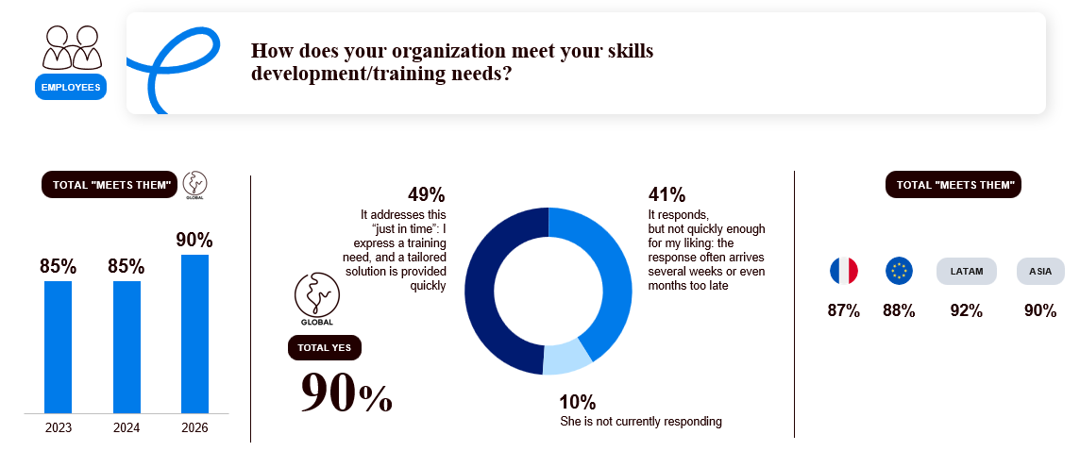

Grégory Gallic, Director of Custom Projects at Cegos, analyses:
“Organisations have clearly recognised the importance of ‘time to competency,’ and most of them claim to be agile in addressing it. But employees’ actual experience is different; they expect an immediate response. Training is also evaluated based on its accessibility, speed of deployment, and operational impact. For Learning & Development professionals, the challenge today is not knowing what to do, but doing it quickly enough and at scale, because expectations are both individual and widespread.”

1 in 4 employees feels or anticipates that their skills are becoming obsolete
On the surface, the indicators are reassuring: skills are recognised as strategic (91% of HR professionals), employees say they are better informed about training offerings (6.9/10), and 68% of HR professionals indicate that they manage career paths, mobility, and projects based on skills.
Yet, behind this positive momentum, a warning sign is emerging: 10% of employees already report no longer having the necessary skills to perform their jobs properly, and 16% sense that this could happen soon.
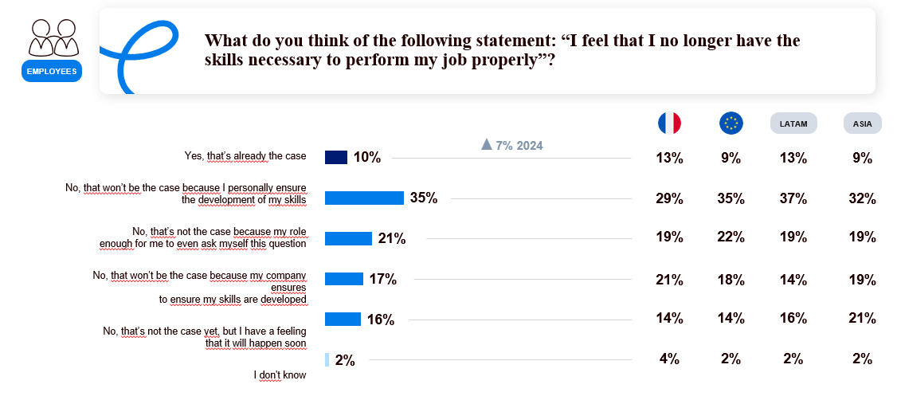
In total, nearly one in four employees already feels or strongly anticipates some form of obsolescence. This figure, up from 7% in 2024, reveals an underlying tension: being better informed does not mean being sufficiently prepared. The accelerated transformation of professions, largely driven by technology, appears both as a factor in obsolescence and as a lever for response.
As Grégory Gallic, Director of Custom Projects at Cegos, points out:
“It’s a faint signal that’s growing louder. When the feeling of obsolescence sets in, training also serves to provide professional reassurance. As skill development cycles accelerate, employees need to feel that their organisation is capable of supporting them at the pace they need. It is also this rapid response that will enable them to remain committed to their own development.”

III – Technology and Generative AI: Rapid, Widespread Adoption… That Hasn’t Fully Infiltrated the Professional Sphere
A technology that is increasingly present… but adoption remains uneven
The proportion of employees who say they feel “overwhelmed” by technology is declining: 35% overall, down from 38% in 2024. Nevertheless, one in three employees still expresses a sense of being left behind.
Geographical disparities remain very significant: 29% of employees in Europe feel overwhelmed by technology, compared to 60% in Asia. These differences may reflect varying rates of adoption. While Europe appears to benefit from a more gradual and socially supported integration of innovations, certain regions in Asia are experiencing massive and ultra-rapid adoption, which can create a sense of “daze” in the face of the scale and speed of these transformations.
As analysed by Carolina Gracia Moreno, Manager of Professional Efficiency Offerings and Expertise at Cegos:
“The feeling of being overwhelmed is certainly diminishing, in part because technology—and generative AI in particular—has become even more visible and accessible. It is seen less as a disruptive force and more as a tool we must learn to live with, adapt to, and use… Nevertheless, with 35% of employees still saying they feel overwhelmed, its adoption in the workplace remains a challenge that companies will have to address.”

Generative AI: widespread adoption, but more personal than professional…
Generative AI is already widely used: 79% of employees have tried it for personal use and 64% for professional purposes. Its use is therefore established, but more so in the private sphere than in everyday work practices and professions.
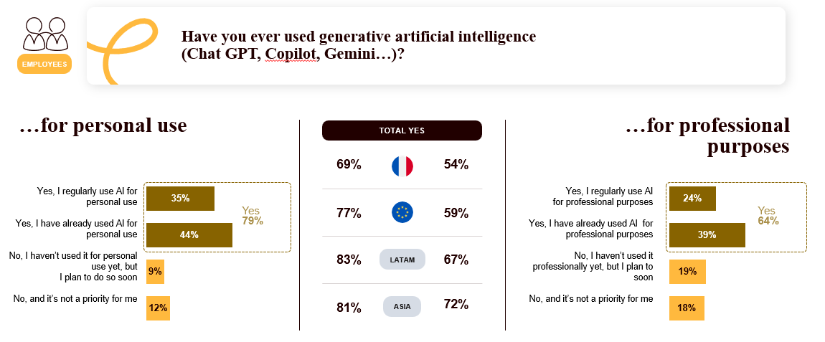
The barriers to adoption in the workplace are well-known: IT department restrictions, privacy concerns, and regulatory frameworks (GDPR in Europe). The risk for organisations is twofold: seeing the emergence of informal “shadow AI” practices and widening the gap in proficiency among employees.
Carolina Gracia Moreno, Manager of Professional Efficiency Offerings and Expertise at Cegos, observes:
“Employees are curious and spontaneously adopt generative AI in their personal lives. Professionally, it’s often more complex. For organisations, the challenge lies in the structured integration of AI in a way that is secure, controlled, and effective. Without a framework or business use cases, AI may remain a peripheral tool, not a true driver of transformation or professional efficiency.”
AI is seen by nearly half of employees as a driver of productivity and creativity...
When asked about the prospects for generative AI, both employees and HR view it primarily as a performance enhancer rather than a threat.
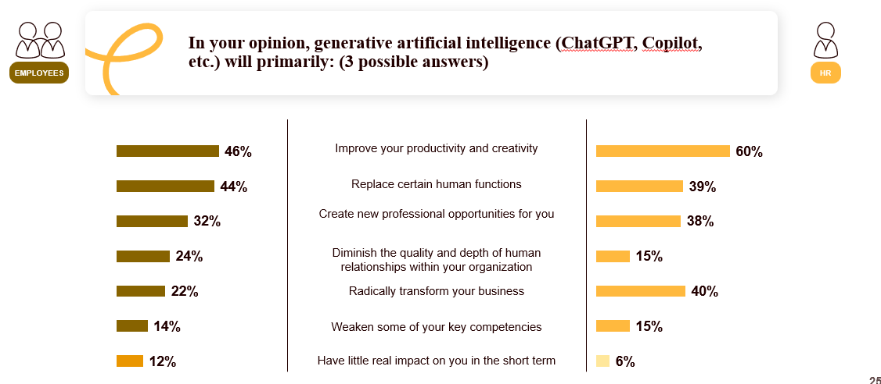
It is worth noting that employees take a nuanced view, indicating that AI will both:
- Improve productivity and creativity (46% overall)
- Replace certain human roles (44% globally)
- Create new career opportunities (32% globally)
As Carolina Gracia Moreno, Manager of Professional Efficiency Offerings and Expertise at Cegos, points out:
“Employees take a positive, yet realistic, view, clearly recognising the potential benefits of AI while acknowledging the risk that it may replace them in certain tasks. They see the benefits but also the impacts, and understand that some roles will evolve or even disappear.”
On the HR side, the perception of AI is more focused on performance and transformation:
- 60% anticipate a productivity gain
- 39% foresee a profound transformation of job roles
- Only 6% believe that AI will have little impact in the short term, compared to 12% of employees
HR adopts a vision of AI that primarily focuses on transformations at the organisational level. Employees, on the other hand, gauge the impact through the practical reality of the tools, the time required to master them, and the necessary adjustments to their daily work.
As Grégory Gallic, Custom Project Director at Cegos, summarises:
“What’s interesting is that AI isn’t primarily perceived as a social threat, but as a lever for organisational transformation. For HR, the question isn’t so much ‘Will AI replace?’ as ‘How will it redistribute the value of work?’ This involves rethinking key competencies, the balance between automation and human expertise, and above all, supporting managers through this restructuring. Training then becomes an indispensable tool for strategic alignment between technological performance and human performance.”
8 out of 10 HR professionals say they are ready to integrate AI into their roles… but only 28% of organisations have formalised and shared guidelines for its use
84% of HR professionals globally say they are capable of integrating, within three years, the impacts of technological advancements (AI, automation, data) on their organisation’s business lines. This high level of confidence reflects an awareness of the transformations underway.
Nevertheless, while intentions are strong, the structural frameworks needed to integrate and deploy AI are not yet fully in place. As evidence, only 28% of organisations have formalised and shared guidelines regarding the use of AI with their employees, while 48% indicate that these guidelines are still being developed.
In other words, the use of AI is taking hold, but the framework has not yet stabilised.
Regional dynamics vary, with Asia appearing to move more quickly in formalising rules.

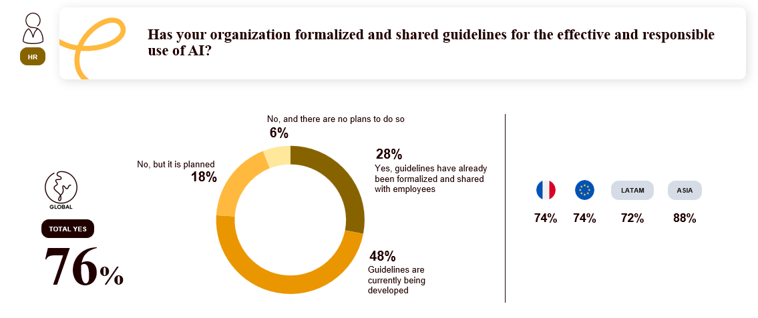

Employees are embracing AI... primarily on their own
Nearly 1 in 2 employees report having already trained themselves in generative AI over the past 12 months, in a spontaneous and informal manner:
  - Through personal experimentation (testing, tools, online self-training) for 25% of them overall
  - Through exchanges with peers (sharing experiences, training) for 25% overall

In contrast, only 16% of employees report having received training through a community of practice or experimentation offered by their company, and 16% through formal training offered by their company.
It is worth noting that 32% of employees would like to receive training but have not yet done so.
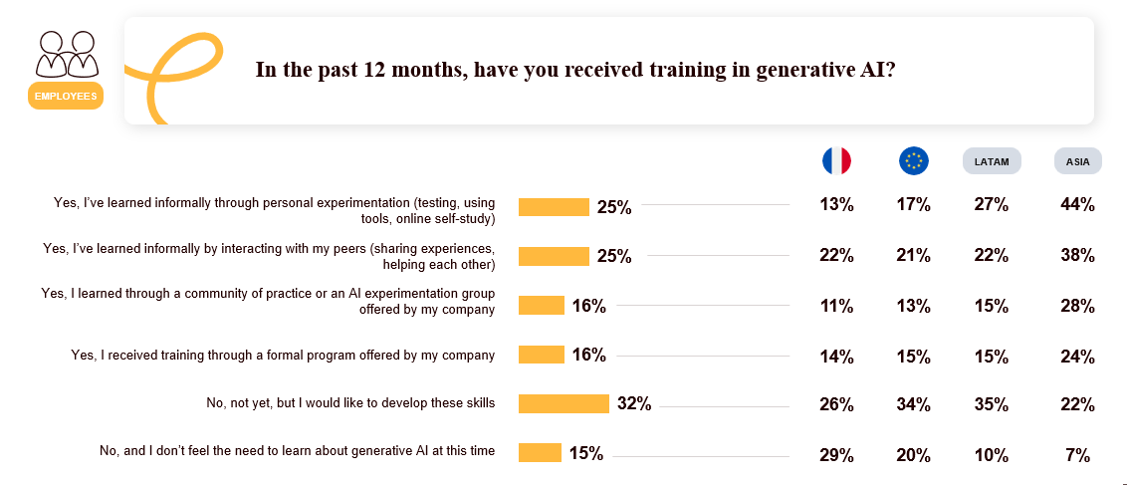
Grégory Gallic, Custom Project Director at Cegos, comments:
“Since AI has rapidly and massively entered the personal sphere, a disconnect persists in the professional context. Some employees have spontaneously experimented with AI in their work, but not all organisations have yet established guidelines or provided support for the use of these tools—far from it. This presents an opportunity, as some employees are curious, engaged, and already using AI, but it also carries several risks: opportunistic learning, a false sense of mastery, a lack of ethical and security frameworks, and inconsistent practices... The training function therefore has a crucial role to play in ensuring that AI becomes a real driver of efficiency.”
In reality, there is currently a wide disparity in maturity among organisations: some are still at Level 1 AI awareness (introduction to prompting), while others are deploying advanced business use cases— —or developing their own LLMs to overcome adoption challenges or risks associated with consumer-grade AI tools.
Grégory Gallic, Custom Project Director at Cegos, explains:
“When it comes to AI, the role of Learning & Development is, in a way, to channel the teams’ spontaneous energy: structuring modular learning paths embedded in workflows, ensuring skill development that incorporates responsibility, critical thinking, legal frameworks, and data security. In other words, it involves transforming an intuitive and personal practice into a mastered professional skill, beneficial to both the individual and the organisation.”

IV – Training & L&D Organisation: Today and Tomorrow’s Challenges
Training: formats that have changed little… and in-person learning remains the cornerstone
Training methods have changed very little since 2024: in-person training remains the majority (55%). Distance learning accounts for 45%, with a relatively stable balance between synchronous training (56% overall,) and asynchronous training (44% overall).
The preference for in-person training reflects the importance organisations place on group dynamics, peer interaction, and guided practical application. Blended learning thus continues to emerge as a balanced approach: combining flexibility and interaction, operational efficiency, and pedagogical quality. More than the contrast between formats, it is their intelligent integration—aimed at driving impact and practical application in the workplace—that is becoming strategic.
As Carolina Gracia Moreno, Manager of Professional Effectiveness Offerings and Expertise at Cegos, points out:
“Hybrid and remote formats are now common in training as well as in the workplace, but the key point to remember is that training remains, above all, a social activity. Regardless of the formats used, human interaction remains central to the learning process; it is what ensures the learner’s engagement and the application of what they’ve learned to their daily work.”
Today and moving forward, 6 out of 10 HR professionals prioritise “learning on the job”: training rooted in action and daily work
Far beyond the debates over in-person versus remote learning, a clear trend is emerging because it is linked to the impact of training: HR professionals overwhelmingly favor training programs directly linked to action and performance.

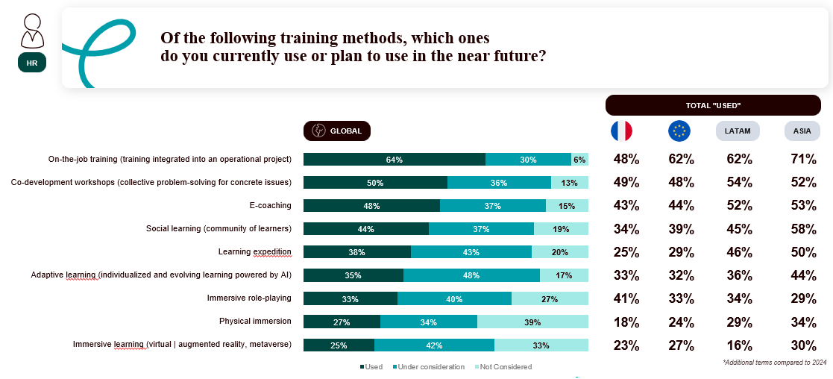
On-the-job learning is therefore emerging as a priority worldwide (64% of HR professionals report using it), ahead of co-development workshops (50% of HR professionals globally) and e-coaching (48% of HR professionals globally).
As Carolina Gracia Moreno, Manager of Professional Effectiveness Offerings and Expertise at Cegos, points out:
“What these figures show is a shift in the center of gravity of Learning & Development. The question is no longer about choosing a format, but about ensuring the impact of training. The approaches gaining traction are those that tangibly reduce ‘time to competency’ by embedding learning in real-world work situations. This transformation is both pedagogical and organisational. It involves integrating learning into the flow of work, rather than treating it as a separate activity.”
Integration into the workflow, accessibility, and support: the winning trio for engaging learners in their training
When asked about the factors driving engagement in training, employees and HR professionals agree on three key elements: the integration of training into real-world work situations, easy and constant access to educational resources, and support from a mentor or trainer.
Integration into real-world work situations ranks first (68% of employees globally / 70% of HR professionals globally). This priority reflects the desire for training to deliver immediate utility and impact, both for employees themselves and for organisations.
Unrestricted access to learning resources at any time (60% of employees and HR professionals) comes in second place, confirming the need for a quick response to one’s needs in order to immediately put what is learned into practice.
In third place, employees and HR professionals overwhelmingly favor support from a mentor or trainer (48% of employees / 55% of HR professionals). In the age of AI and digital technology, feedback, perspective-building, and interaction with another individual help ensure the mastery of skills and the embedding of practices.
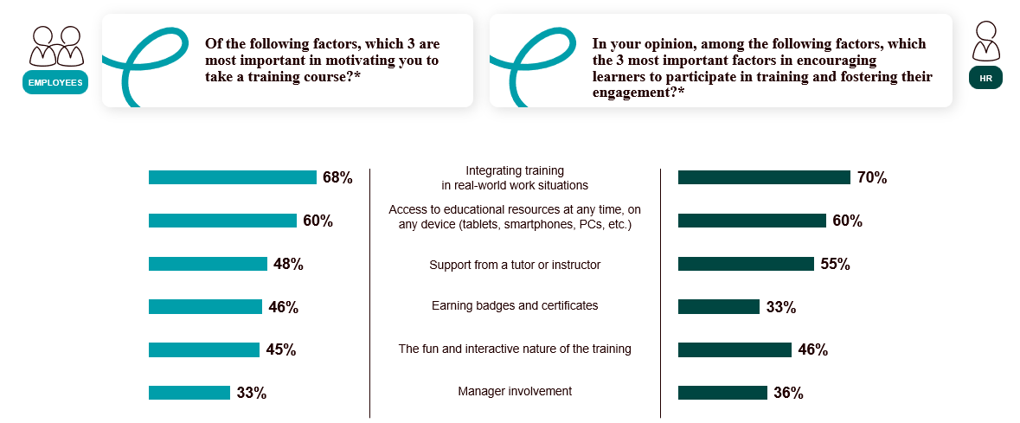
Another finding from the study is a gap in perceptions regarding badges and certificates: 46% of employees see them as a key factor in engagement, compared to 33% of HR professionals. While two-thirds of HR professionals wish to manage by competencies, these badges and certificates nevertheless represent forms of recognition that are useful for mobility or career advancement and important to the employees themselves.
The future of training? Integrated into daily life, immediately applicable, and personalised
When asked how training should evolve, employees and HR professionals agree: the priority is to promote on-the-job training and immediate application. This is the top priority for HR (59% overall) and for employees (43% overall), in response to the challenge of time to competency.
Other expectations are emerging: more personalised learning paths (40% HR / 33% employees), greater interactivity (34% HR / 32% employees), and a faster response to needs (31% HR / 32% employees).
Taken together, this reflects a transformation of the L&D model: the shift is from a catalog-based approach where training is activated on demand... to a model of continuous learning and adaptation, integrated into the workflow.
AI for training: 63% of organisations are already on this path…
When asked, “Do you use or plan to use generative artificial intelligence for training?”, nearly two in three organisations (63%) report having already implemented it (27%) or having plans to do so (37%). France is slightly below the global average (56%), while Latin America (71%) and Asia (68%) are moving more aggressively in this direction.
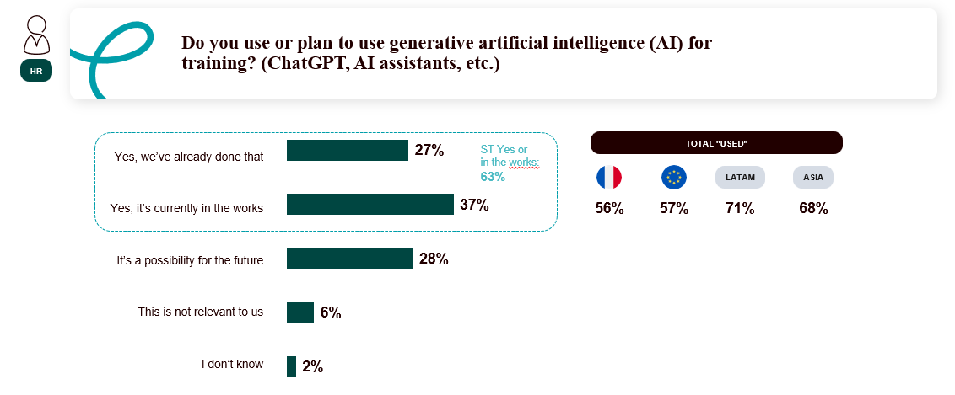
Grégory Gallic, Director of Custom Projects at Cegos, analyses:
“Generative AI is beginning to be integrated into training programs in a structured way. The real challenge for Learning & Development departments is no longer to test the tool, but to scale it up: how can AI be used effectively, ethically, and at scale? How can we turn it into a catalyst for acceleration without compromising educational value, learning path consistency, or accountability? The challenge now is to establish clear guidelines, ensure the secure use of AI in training, and align it with a clear skills strategy.”
… and nearly 6 in 10 HR professionals say they use AI to personalise training pathways
When asked, “Do you use or plan to use AI to personalise training pathways?”, 57% of HR professionals answered yes or that it is in the works, representing a 20-point increase over three years (37% in 2023, 49% in 2024, 57% in 2026).
More than one in two organisations now considers AI a key tool for personalisation.
This personalisation encompasses several dimensions: AI can enable the implementation of adaptive learning strategies, power personalised recommendation engines, facilitate skills assessment, and pave the way for dynamic modularisation of learning paths, tailored to the actual needs and pace of each learner.
Toward data-driven governance of L&D systems…
When asked how they use learning analytics, HR professionals primarily cite improving the learning experience (42% overall). In line with the priorities mentioned above, they also highlight the individualisation of learning paths (25%, up 15 points from 2024), confirming the rise of a data-driven personalisation approach. Managing the learning offering (23% overall) is also becoming a key focus.
… and measuring the impact of training on operational performance
Regarding the indicators used to measure the performance of training programs, a shift appears to be underway, as for the first time, HR professionals cite measuring the impact of training on operational performance as their top priority (55%, up 8 percentage points compared to 2024) ahead of measuring learning outcomes (54% overall) and trainee satisfaction (53% overall). This trend signals that training is shifting toward a focus on measurable contributions to performance.
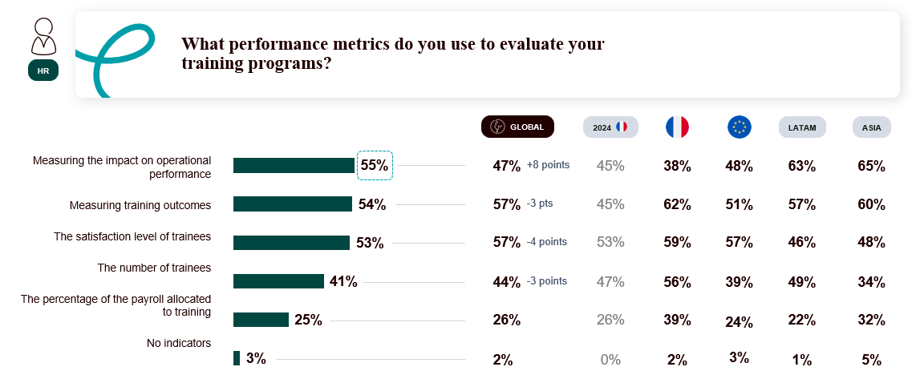
As Grégory Gallic, Custom Project Director at Cegos, summarises:
“Training is now judged by what it actually changes in the workplace. Impact measurement therefore becomes a lever for strategic legitimacy for L&D functions, which must shift from a focus on demonstrating activity to demonstrating impact. But the challenge of systematically linking initiatives, competencies, and business indicators requires both robust data structuring and a cultural shift for L&D, as well as for the company.”
By 2035: Training as a Lever for Human Differentiation
When asked, “By 2035, what will be the main challenge for training? ," employees and HR professionals agree that its differentiating value will lie above all in the development of human skills: 23% of employees and 21% of HR professionals cite the need to develop the skills that distinguish humans from AI as the top priority.
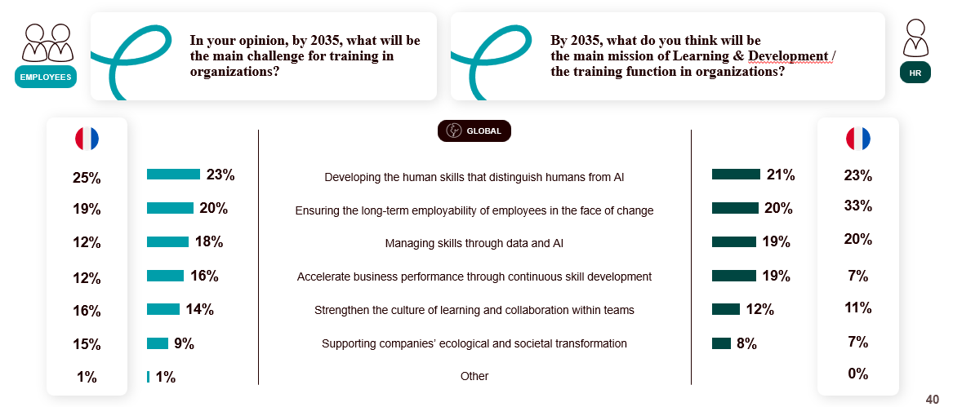
This response seems to suggest that as AI automates tasks, organisations will need to invest in developing specifically human capabilities: critical thinking, creativity, emotional intelligence, cooperation, ethical judgment…
Training will therefore be tasked with strengthening this “augmented human capital,” which complements technology.
According to the employees and HR professionals surveyed, training also lies at the intersection of two key priorities: ensuring the long-term employability of teams (20% of employees globally / 20% of HR professionals globally) and managing skills through data and AI (18% of employees / 19% of HR professionals).
Finally, it is worth noting that supporting ecological and societal transformation ranks last (9% of employees / 8% of HR professionals). This ranking seems to indicate that these major macroeconomic challenges have not yet truly entered the scope of the training function.
Grégory Gallic, Custom Project Director at Cegos, comments:
“The vision that employees and HR managers share with us regarding training by 2035 reveals two sides of the same coin: on the one hand, training that is increasingly connected to business challenges and technological changes; on the other hand, training centered on people and on what technology cannot replace.”
The Cegos Group, which is celebrating its 100th anniversary, has also chosen to ask the following question this year
“If you could send a message to a future employee
working 100 years from now, what would you say to them?”
The employees’ choice: “Cultivate your curiosity: it is the key to continuous learning.”
HR’s choice: “Always value the strength of the collective: we make the most progress when we work together.”
Employees seem to have understood that curiosity and a desire to learn will always determine adaptability and employability. HR, for its part, values the strength of the collective as a timeless driver of engagement and competitiveness.
One hundred years after its founding, Cegos remains firmly at the intersection of these concepts, upholding the belief that the development of individual and collective skills has always been—and will always remain—at the heart of all progress.

Media Contact: Flora Milteau-Garnier -fmgarnier@cegos.fr – +33 06 88 21 97 30

About the Cegos Group - www.cegos.com
Founded in 1926, the Cegos Group is an international leader in Learning & Development. The Group has direct operations in 13 countries across Europe, Asia, and the Americas. It is also present in more than 50 countries through a network of partners and distributors, including leading training providers and major technology companies.
With 1,500 employees and over 3,000 partner consultants, the Group trains 250,000 people worldwide each year and generates revenue of 250 million euros.

To fulfill its mission—training individuals and supporting organisations to meet their development challenges—Cegos offers a comprehensive range of services, including off-the-shelf and customised training, operational consulting, training outsourcing, and international training projects. Its “blended learning” approach aims to provide the most tailored and competitive learning experience by combining multiple teaching methods (in-person training, e-learning modules, videoconferences, videocasts, e-learning courses, etc.).
Follow us on LinkedIn

