Press Release

Early Black Friday deals at Books2Door

- An EXTRA 10% off in our SALE collection for the entire month of November (discounts already applied)
- 20% Cashback on all orders during Black Friday Weekend (Friday 24th – Monday 27th November)
- Half-price PLUS+ Delivery for Black Friday Weekend (Friday 24th – Monday 27th November)

Award-winning online book retailer, Books2Door is having an early Black Friday sale with amazing offers for everyone ahead of Christmas – including an extra 10% off!
With someone for everyone, customers can find bargain deals across books for children and adults in the hand-picked selection under their ‘Black Friday Sale’.
What’s more, during Black Friday Weekend - customers can also benefit from 20% cashback on all orders under the Books2Door loyalty membership scheme when they sign up to BookPoints via the website during this period.
There will also be an opportunity to purchase an annual free delivery pass at 50% off, costing only £4.95 instead of the usual £9.95.
Included in the ‘Black Friday Sale’ are bestsellers and all-time book favourites with an extra 10% off the RRP.
Customers can expect to find well-known titles and authors including Numberblocks, Bluey, Sherlock Holmes, Julia Donaldson, Jill Tomlinson, Tom Fletcher, Stephen King and more!
Check out Books2Door’s top picks in the Black Friday Sale.
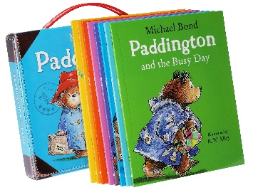

Paddington – Suitcase of 8 books
Only £8.99
A total of 40% off RRP
Dr. Seuss – 20 Book Set (hardback)
Only £57.99
A total of 52% off RRP
Bluey – 10 Book Set
Only £17.99
A total of 70% off RRP

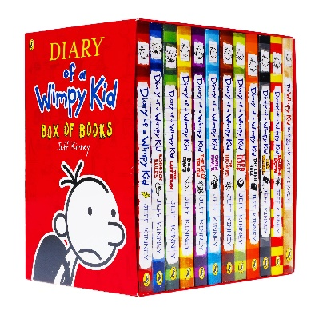
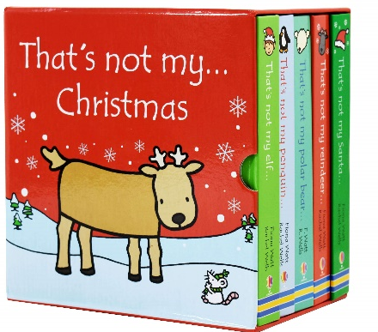

That’s Not My Christmas –
5 Book set
Only £18.99
A total of 46% off RRP
Diary of a Wimpy Kid
Only £24.93
A total of 74% off RRP
Stephen King – 8 Book Set
Only £39.99
A total of 52% off RRP

Where’s Wally – Super Six Collection
Only £16.50
A total of 67% off RRP
Ann Cleeves – 8 Book Set
Only £20.99
A total of 71% off RRP
Football Rising Stars – 10 Book Set
Only £13.99
A total of 80% off RRP

Ends
For further information, please contact:
Jasleen – jasleen@books2door.com / 07469196338

About Books2Door
Books2Door is an award-winning, national online retailer specialising in children’s book sets and series. With a mission to make books more affordable, accessible as well as offering a diverse range, they promote less screen time and more story time to encourage a love for reading. To support parents, they offer book sets with up to 80% off all year round.
https://www.books2door.com/

