Press Release 27 October 2022

Spiritual and Social Mediumisms: Post-Apostolic Manipulations [SSM]
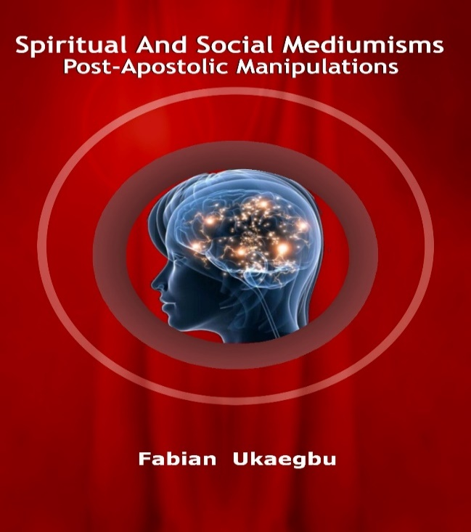
Mediumism is an intuitive capture of a spiritual message. Also called Mind-Walking, mind-walkers use it to modulate their arts and acts. Mediumism is about spiritual energy and the Mind (not the heart) is its medium. We are supposed to be driven by God’s spirit but often friends, foes or desires manipulate us; hence, from God, mediumism is a spiritual drive but amongst men, it is social arts and acts.
Religiosities have peaked. Our time tasks anew as SSM prepares for post-event life in which those who survived shall not live together without binding themselves conveniently. Many people are naive and make vague vocal sense of Jesus. Our education is frail. The main virtue of education is ability to notice change of topic and what could cause it? Did Jesus leave his identity to guesswork? Post-Gospel: Apostleship stretched to AD99; the church did not mention Trinity. The Gnostics began about 4th century AD to twist to Hypostasis or Binitarianism & Trinitarianism and twisted Jesus’ Covenant to Communion. Is the rivalry that led to death about who dies for others to live?
Communication with God; what is the topic? Ponder men seeming religious but God is not religious, as religion alone does not drive life. What was the nature of the persecution that continued to AD313? Do you agree with Covenant becoming Eucharistia; Abortion raging bread war; idolatrous iconism and your being taught in foreign languages? Is the Nicaean Creed measureable? Don’t hate/love as others, have your unique stand.
“My yoke is light and my burden is easy”. His yoke was to prove God and his proofs were his miracles, which attracted envy from rival religions. His yoke tasked him dearly. Saul had acted against Stephen; on his way to Damascus to do more harm; he was halted but saved – is it loving your enemy? No; it was justice postponed and judgment enlarged. The Great Roman Empire treated Christianity as rival to Hellenism but notice as Paul died, the Great Roman Empire split in AD395 and the East, the Core-Hellenism faced Islamic conquests. The irony was, after these ominous events; the Islamic allies fought for their independence from 1921 – is it religion?
We passed the peak of religiosity in 1978 and literary dominion in 2011, what did we learn? We may be religious but the work of God comes from God. Not to know God is a misfortune. Do not let the devil wish you well, which is hell. Beware of neighbours in mutative desires that drive like wine.
Mind-walking is about the mystery of life. If mastering yourself is the only goal you achieved before 2096, you will survive the portents thereafter. Babies play with toys but men covenant to check their relationship – this is the summary of evolution.
Book details
Number of pages: 454 A5, Paper back, Price: £15.95

