New Study by AirPop run on YouGov Direct Finds that Over 60% of the British Public Will Still Wear Masks

76% of 18-24 year olds say they are likely to wear a mask around elderly and vulnerable people

5th April 2022, London, United Kingdom - Today, a new study conducted by YouGov and AirPop highlights the future of masking in the UK. With over 1000 respondents, the study found that over 60% of the British public will continue to wear masks moving forward. Caring for others is a key driver with 76% of individuals aged 18-24 saying they would continue to wear masks to protect the elderly and vulnerable. Personal protection was another reason, especially while shopping, at crowded events and on public transportation. The data highlights the transition of masks from a pandemic mandate to a matter of personal choice - indicating that more Americans have embraced face masks as an important tool in the protection of their health and well-being.
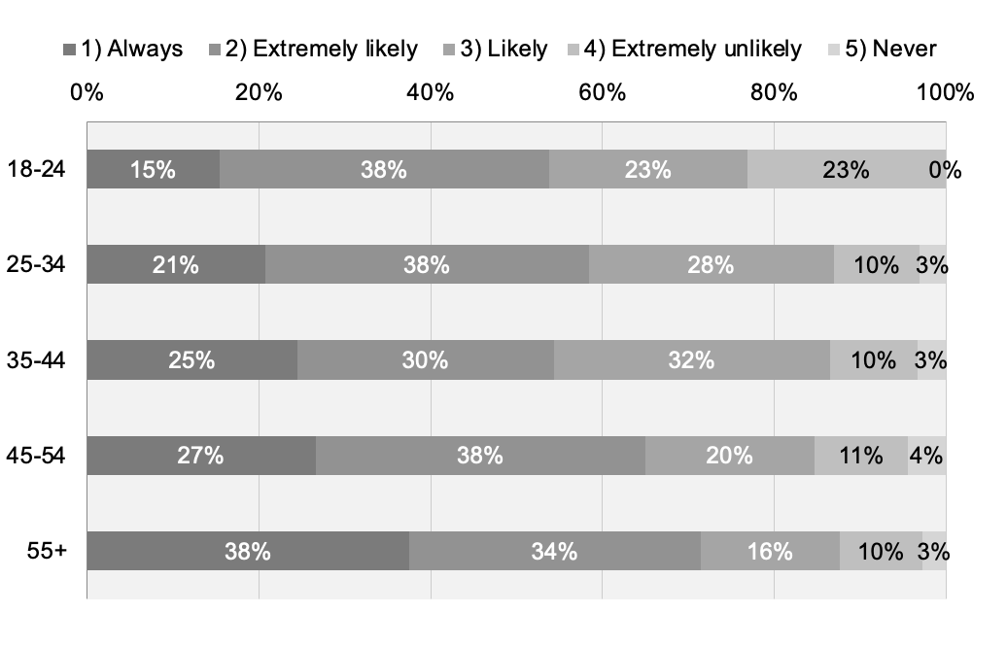

Graph: results to the question How likely are you to wear a must when you are in close proximity with elderly or vulnerable people

The survey was conducted on YouGov Direct. 1,000 UK adults 18+ were interviewed on 17th March 2022. Data is weighted on age, gender, education level, political affiliation and social grade to be nationally representative of adults 18+ in the United Kingdom. The margin of error is approximately 3.3% for the overall sample.

Simon Neave, CCO AirPop Health, comments: “We were keen to understand what the UK public thought as we start to learn to live with COVID. What’s clear from this survey is that the message of ‘hands, face, space’ still rings true for most and the majority of respondents are willingly adapting their behaviours to protect themselves and show true compassion for the elderly and vulnerable.”

“We are delighted to see AirPop health using primary research to keep abreast of consumer behaviour while society continues to live with Covid. Empathy for others is clearly a driver for most of the population today and that importance translates into the workplace and retail.” comments Ted Marzilli, CEO, YouGov Direct.

Key Factors Driving Masking
- 55% of respondents wear a face mask because they care about others. 54% of 18-24 year olds wear a mask as an outward sign that they care about others - more than any other age category only 26% in the 40-54 age range)
- 40% say they are worried about catching Covid-19
- 76% of respondents 18-24 year olds said they were likely to wear a mask around elderly and vulnerable people
Where Individuals Will Wear Masks
- 76% of people said they will continue to wear a face mask on public transport (over 79% in the over 55s and female categories)
- 69% of 18-24 year olds said they would wear a face mask on public transport to make others feel comfortable (compared to 20-27% in the older age ranges)
- 42% of people said they would always a wear a face mask while shopping at a retail or grocery store to protect themselves
- 0% of 18-24 years olds said it was unnecessary for people to wear face masks in bars, restaurants and shops (compared to 16% of 40-54 year olds)

Overall Impact of the Pandemic in Individuals
- 56% of respondents said they will continue to socially distance and avoid crowded places
- 60% of people said they will continue to wear a face mask in the future (67% of over 55s)
- 52% of respondents said the pandemic will have lasting effect emotionally

Full study available here

About AirPop
AirPop empowers you to take control of the air you breathe anytime, anywhere you need it. Since 2015, our material and design innovations have delivered comfortable fit and daily wearability for millions of people, while exceeding all professional mask standards for filtration and breathability. AirPop masks deliver superior performance by solving three critical issues: fit, filtration and breathability. The revolutionary mask design includes a patented seal ensuring a secure fit, while the 3D Air Dome increases airflow for better breathability and comfort. Furthermore, AirPop masks combine a 4-layer filter material to create a barrier down to 0.3 microns achieving greater than 97% efficiency in accredited laboratory tests. For more information visit: www.airpophealth.com.

Press contacts:
Gemma Stenberg
AirPop UK Media Relations
gemma@olexcommunications.co.uk
+44 7854 813 153

Simon Neave
Chief Commercial Officer
simon.neave@strax.com

