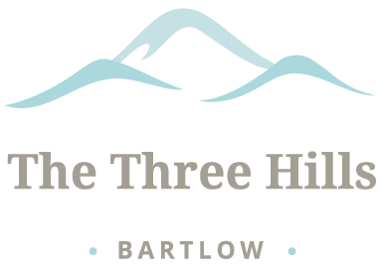

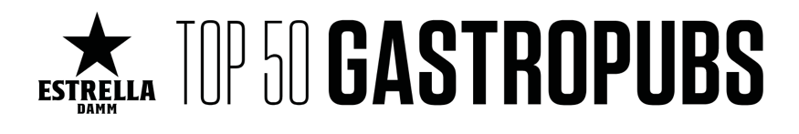

For immediate release

The Three Hills Bartlow, Cambridgeshire wins Highest New Entry Award with The Estrella Damm Top 50 Gastropubs 2021 Awards and Number 22 in their 2021 List.

The Three Hills Bartlow has been awarded Highest New Entry in The Estrella Damm Top 50 Gastropubs for 2021 and Number 22 in their 2021 List, adding to their Michelin Plate and two AA Rosettes. The Estrella Damm Top 50 Gastropub Awards are voted for by top foodies and hospitality experts. The voting criteria ensures the list really is decided by the industry itself.

The Three Hills Public House is a Grade II listed 17th century timber framed building in the heart of Bartlow. This charming dog-friendly country pub with an award-winning restaurant has six luxury ensuite rooms, an orangery, an extensive covered patio and landscaped gardens. It is located close to Cambridge and about an hour from London. Purchased by owners Chris and Sarah Field in December 2015 and lovingly restored and refurbished, The Three Hills reopened its doors two years later in November 2017.

Chris Field said, “I am beyond proud of what we have achieved in the short period of time we have been open. Like bamboo, the first year we slept, the second year we crept and the third year, despite the last difficult 12 months, we have leapt!. At its heart, this is an historic village pub. We feel that we have now given it a stronger heartbeat that appeals to what village and community means today, which is all the more poignant due to COVID. The Three Hills has become both a destination and a village pub for a much wider community. He added, “To be recognised by the Estrella Damm Top 50 Gastropubs is testament to the hard work and dedication of our super talented team and to the support of our local and wider community. After such a difficult year we are thrilled with this latest accolade and truly delighted that Bartlow is now firmly on the map!”

Emma Harrison said, “this is a phenomenal achievement by the whole team at The Three Hills, and we are beyond proud to have been included in such an esteemed list of UK pubs.”

For further information visit https://www.top50gastropubs.com/

End / Word Count 365

Notes to editors
For additional quotes or information please contact:
Emma Harrison, General Manager
T: 07785 931803
E: emma.harrison@thethreehills.co.uk (for editors only)

About The Three Hills Bartlow
The Three Hills is a charming dog-friendly country pub with six luxury ensuite rooms, an orangery, an extensive patio and beautiful landscaped gardens with an award restaurant located close to Cambridge and about an hour from London. This recently restored and renovated 17th Century Grade II listed building is located in the heart of Bartlow, and is the only remaining pub and community facility in a small village of only 110 residents. Originally opened as an alehouse in 1847, The Three Hills is named after the three hills or Tumuli, ancient burial mounds originally part of a seven mound group which are considered to be the largest in Europe.
For further information visit https://www.thethreehills.co.uk/
The Three Hills, Bartlow, Cambridge CB21 4PW
https://www.instagram.com/thethreehillsbartlow/
https://twitter.com/TheThreeHills2
https://www.facebook.com/thethreehillsbartlow

About The Estrella Damm Top 50 Gastropubs

The Industry’s Choice
The “Estrella Damm” Top 50 Gastropub Awards are voted for by top foodies and hospitality experts. These include gastropub operators (who can’t vote for their own pubs), food writers, pubco catering development managers and executive chefs, celebrity and top hospitality industry chefs, pub guide editors, industry chiefs and food operators. The voting criteria ensures the list really is decided by the industry.

Judging Process- Top 50
To ensure that each region in the UK has an equal opportunity for their pubs to shine, our voters are broken down into six geographical regions, with an equal number of votes collected in each by the Top 50 Gastropubs Voting Academy. Our regional academy chairs include food writers and experts.
The Morning Advertiser editor Ed Bedington says: “Winning or being shortlisted as a finalist is an excellent way of getting your pub – and yourself – the recognition that you deserve. Getting on this list is the jewel in the crown for foodie pubs across the UK. It’s the place to be seen.”
Votes are cast in a poll of hundreds of industry experts, including top chefs, food writers, pubco chiefs, pub-guide editors and top suppliers to bring you this definitive list of the best gastropubs in Britain.

For further information visit https://www.top50gastropubs.com/
