Verifile
5 Franklin Court
Priory Business Park
Bedford
Bedfordshire
MK44 3JZ

23 November 2020

Ref: UK Business Hero

Dear Eyal

In October British Chambers of Commerce alongside the local Chamber network, launched a campaign to recognise the incredible work UK businesses have been doing to support local communities, innovate and meet new demands during the Coronavirus pandemic.

The UK Business Hero stamp was created to pay tribute to those businesses and individuals that have gone the extra mile and make a vital contribution in these difficult times.

We nominated Verifile for your pledge of £3 million to support coronavirus recruitment by waiving all DBS admin fees for health and social care roles treating COVID-19. I am delighted to inform you that due to your efforts you have been awarded the UK Business Hero stamp.

Bedfordshire Chamber of Commerce would like to congratulate Verifile and all the staff involved for their contribution and responding to the needs of frontline workers and the local community.

Please see attached a letter of congratulations from HRH The Countess of Wessex GCVO.

Regards

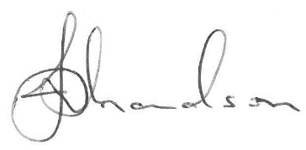

Justin Richardson
Chief Executive

