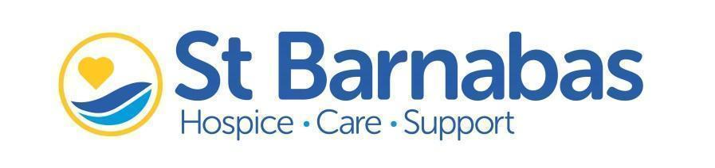

N E W S R E L E A S E

**FOR IMMEDIATE RELEASE**

21st July 2021

**Hospice Devastated by Damage To Imp Sculpture**

**Statement from** [**St Barnabas Hospice**](https://stbarnabashospice.co.uk/about-us/)**:**

**It is with great sadness that we are reporting overnight damage to one of the imps on the Lincoln Imp Trail.**

The Community Imp has been damaged, which is devastating news for all involved in the Trail. This particular imp was designed by a local school child from Gonerby Hill Foot Church of England Primary School, which makes the vandalism all the more heart-breaking.

As charity partner for the Lincoln Imp Trail, this will impact us financially, particularly whilst the imp is removed from the Trail for repairs. Each imp is a donation point, meaning supporters can scan a QR code and give to the Hospice as they complete the Trail.

Chris Wheway, Chief Executive at St Barnabas Hospice said, “I am shocked to see the vandalism of the Community Imp in Lincoln city centre. This is disappointing for the child who has designed it, the artist (Sian Bristow) and Trail organisers (Lincoln BIG). We hope the damage made to this imp can be repaired, as in these difficult times we are reliant on this vital fundraising.

“As the trail’s charity partner, any funds raised from the Trail will go directly to St Barnabas Hospice to support the people of Lincolnshire with life-limiting or terminal illnesses. We are hopeful that this will be a one-off incident and that people continue to give generously to help our vulnerable patients as they complete the Trail.”

Thanks to fast action from Lincolnshire Police, we are relieved to hear that the suspect was tracked down through CCTV and arrested shortly after the incident.

**ENDS**

**Notes for Editors:**

1. For more information, contact Hannah Dawson, Marketing & Communications Officer on 07483 300 503, [hannah.dawson@stbarnabashospice.co.uk](mailto:hannah.dawson@stbarnabashospice.co.uk)
2. St Barnabas Hospice is a local independent charity and every year they support more than 10,500 people across Lincolnshire. They deliver free, high-quality, compassionate end-of-life care and support to people living with a life-limiting or terminal illness, their family and carers. St Barnabas offers the patient and their family hospice care and support via: specialist inpatient care, care at home, day therapy, physiotherapy, occupational therapy, complementary therapy, welfare advice and bereavement support. All the services are free. St Barnabas needs to raise over £6m a year to provide its support and care. Over 900 volunteers play a crucial role in the charity’s success.
3. [www.stbarnabashospice.co.uk](http://www.stbarnabashospice.co.uk)