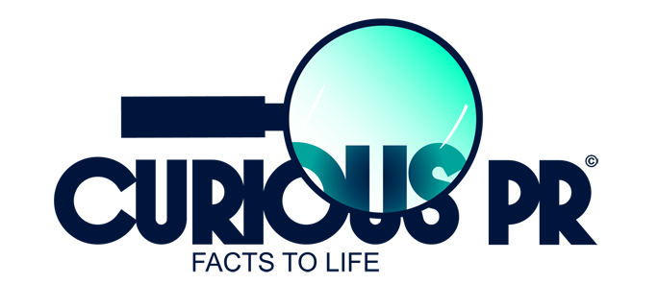

PRESS RELEASE
The UK welcomes its first pan-European dental provider, Colosseum Dental
One year after taking ownership of the UK’s third largest dental group, Zurich-based Colosseum Dental Group unveils a £5M comprehensive modernisation programme focused on clinical excellence and best practice

“We’re really excited to be part of a pan-European group which is in the vanguard of best practice. We’re looking forward to sharing knowledge and outcomes, enabling us to push dental boundaries and enrich the dental experience for our patients.”
- Ravi Rattan, Clinical Director, Colosseum Dental UK Ltd

15th March 2018 [LONDON] Southern Dental, the nation’s third largest chain of dentists, is now known as Colosseum Dental UK Ltd. The name change coincides with the first anniversary of Zurich-based Colosseum Dental's acquisition of Southern Dental, which made it not only Europe's fastest growing dental group, but also the only one with a network spanning the continent.
With a patient base in excess of 500,000, the majority of Colosseum's 80 practices in the UK will undergo an extensive refurbishment programme, introducing a new look and feel to waiting rooms with upgraded treatment areas and clinical facilities as part of a £5,000,000 investment in the company. Peter Keegans, CEO, explains, “Our new owners have a long-term, 20-year vision which is enabling us to invest in upgrading our clinics to be state-of-the-art practices offering the highest standards.” Colosseum Dental Group’s ambition is to be Europe’s leading dental provider within five years.
LOCAL PRACTICES SERVING THEIR COMMUNITY
One of the pillars of Colosseum’s recipe for success in the UK will be embedding each practice as a “good neighbour” in its local community. Peter continues, “We want to break with convention from other dental chains. Each of our 80 practices will be known by the local name patients have always referred to it. If, for example, ‘Hollybush Dental’ is how a practice has always been known colloquially, we've no intention of simply re-badging it as ‘Colosseum Dental’. In this way, each practice will retain its connection as an integral part of its community."
In addition to being a good neighbour, Colosseum has two other refreshingly simple cultural values; to be a provider of exceptional patient care and to be a great employer. As Peter explains, “Our name change marks a new era: a renewed energy and focus, an opportunity for cultural change and to align ourselves with the values of our European colleagues. Armed with a long-term vision, we can now invest in our practices and staff with confidence, knowing our patients will be the ultimate beneficiaries. Everyone wins.”
EUROPEAN SCOPE FOR PROFESSIONAL DEVELOPMENT AND PATIENT CARE
Being part of a European group means dentists have the chance to provide best practice based on the ability to observe long-term clinical outcomes in a huge, European-wide patient base. Treatment protocols, guidelines and KPIs are currently being developed across the group to provide highly informed patient care, and present the best possible treatment options to patients. Ravi Rattan, Clinical Director at Colosseum Dental UK, who joined in 2016, is excited to be part of these changes: “At Colosseum Dental, we’re committed to raising clinical standards and offering more advanced treatment options and procedures to our patients. Our new specialist referral centres in Kettering and Kingston offer private as well as NHS treatments such as orthodontics, implants and facial aesthetics. Patients there will benefit from 3D CBCT scanners to enable better, safer treatment planning. Having new investment means we can continue to set up such centres: Our European colleagues are highly experienced in managing large referral centres, and we are learning from their success.”

The group’s aim is for no differences to exist between treatments available at, say, a practice in Switzlerand, and those available at one in Southern England. Lars Armbäck is Chief Dentist at Colosseum Dental Group. Armed with 30 years’ general practice and a special interest in prosthetics, implants, quality and treatment strategy, his focus is on best practice, dentist development and quality assurance. He’s excited by the addition of the 80 English clinics, noting, “Patients everywhere should be able to benefit from digital technologies that enable them to make informed choices about their care. Hence, as a group, we recently chose to invest in intraoral scanners for all patients, and our size means we can negotiate to help keep diagnostic and treatment prices affordable.” He adds, “Dentists at our UK practices will benefit from committees we have set up to examine best practice in treatment planning and workflow. With time, we’ll be able to compare patient outcomes across Europe, and thereby identify best treatment strategies and best practice overall. It’s this type of sharing which sets us apart from any of our competitors.”
COMMITTED TO PROFESSIONAL DEVELOPMENT
Career choices at various levels are being made more flexible, in line with changing lifestyle requirements such as increased female and part time dentists in post. Samaneh Nezamivand-Chegini, a dentist who practises in Central London, having joined in 2012, now sits on the Clinical Board. She says, “It’s great to see my suggestions have been noted, despite my being relatively newly qualified. Peter [Keegans] and his team have listened and acted, which is in turn inspiring my clinical colleagues. On a personal level, I’m being supported to further my career and income via training in implantology.”
Sharyn Wilson, HR Director at Colosseum Dental UK, notes, “Our improved ways of working and communicating are being appreciated by all our staff, from receptionists to dental specialists.” Career progression for non-clinical staff is also being strengthened. For example, the new Advanced Treatment Co-ordinator has progressed from earlier roles as nurse, Practice Manager, then Resourcer. As a sign of its commitment to professional development, Colosseum Dental UK will hold its first Annual Conference on 20th April, where keynote speakers will include Seema Sharma, an expert in transforming dental practices, Joe Bhat, a Fellow of the International Team for Implantology and Jas Gill, who was voted in at No.12 in the Top 50 most important people in UK Dentistry.

ABOUT COLOSSEUM DENTAL UK LIMITED
Colosseum Dental UK Limited is the third largest chain of dental practices in the UK, with 80 clinics spanning 19 counties. The company supplies high quality general dental care, as well as specialist services for NHS and private patients. It has more than 900 employees and Associates, including over 250 dental professionals, serving more than 500,000 patients. Its mission is to be the ‘best in class’ dental group in the South of England by providing modern, quality dentistry services for the benefit of patients, dentists, employees, shareholders and striving for continuous growth and excellence. www.colosseumdental.co.uk

MEDIA ENQUIRIES

For all enquiries, including interview requests and/or hi-res images, please contact Hannah or Francesca at Curious PR, London Hannah@CuriousPR.com | Francesca@CuriousPR.com
T +44 (0)20 3397 9111|M +44 (0)7747 794306| Insta CuriousPR |Tw @Curious_PR |www.CuriousPR.com

