 | DEVANX RDA®  (RED DIAMOND ASSET)  Market Overview | 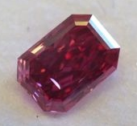
Supply of diamonds will most likely be constricted over the next decade, as key mines in Australia and Canada are milked dry and major mining companies reduce their foothold in the industry. African mines are weighed down politically, with talks over the Kimberly Process (KP) for verifying conflict-free diamonds facing charges of hypocrisy, by the KP organisers’ refusal to boycott Zimbabwe as a supplier.
At the same time, there is a diversity of new, rival market players which means rough and polished stones will stream in an unregulated fashion into growth regions like China and, to a certain extent, India. If there is a fortune to be made in diamonds today, it is in rare coloured stones, the investment-grade fancy vivid varieties so desirable they are rarely seen or traded outside private circles.
A recent report, ‘Diamond Price Outlook, released by Citigroup Global Markets, described the major decline in the rate at which kimberlites (the host rock for most diamonds) are being discovered, as long-term acting to constrict supply of rough uncut diamonds. Citigroup’s report, released to investors and broken by Forbes the week of 24/10/13, stated that while initially diamond prices might dip slightly, or “stabilize”, 2013-14, “the mine supply trend, the structural shift in China, and a slowly recovering global economy should see diamond shortages making their mark on prices in 2015-to-2020.”

BHP Billiton has made its exit from its lucrative Ekati mine in Canada, pre-empting the mine’s decline in profitability. It agreed to sell the Ekati mine to Harry Winston Diamond Mines Ltd for US$500million in November 2012. Late in 2011, BHP Billiton’s 51% stake in the Chidliak diamond project, South Baffin Island, Nunavut, to young Canadian mining firm Peregrine Diamonds.

The reduced prospects of the Chidliak project are indicated by De Beers’ decision not to exercise an option which would have entered it into joint venture with Peregrine Diamonds. If De Beers had decided it was worthwhile, it would have invested $60 million in Chidliak over five years and it would have become the operator of Chidliak, with a majority interest in the project.

Another mining giant Rio Tinto also looks to be scaling down prediction, though it has launched a major diamond marketing drive in China. The firm announced in November it was relieving unknown number of contractors of employment at its Argyle mine in western Australia. The publication The Western Australian estimates 500 Argyle employees have been let go since September last year.
Rio Tinto is deploying its current production surfeit from Argyle in its Shanghai marketing campaign, ‘The Fashion of Diamonds’, which Managing Director of Rio Tinto Diamonds described as the “next phase in our China market strategy.” The scheme incorporates 13 jewellery collections and over 90 pieces of diamond jewellery, created in collaboration with local designers Fei Liu, Huang Chao Yan, Aya Kamimura, Wen Wei Tong, and Zhong Hua.
The stated aim was to tap market demand for diamonds but draw on cultural strands rather than make a fetish of the stones themselves. Rita Maltez, Manager of Rio Tinto Diamond’s Greater China Representative Office, said: “The time is perfect to introduce these stunning new fashion jewellery collections. They are inspired by notions of nature, romance shapes and patterns and are symbolic of a new era… one that will be more design driven than ever.”
China’s appetite for diamonds as an unadorned commodity has been demonstrated by the recent auction in Hong Kong, which set a world record for the highest price a white diamond has fetched at auction, at US$30.6million; though the 7.59-carat brilliant-cut, vivid ‘Premier Blue’ stone failed to attract sufficient bids for sale.
Last year, Bloomberg cited an Anglo-American presentation in November 2012 which stated that Indian and Chinese demand would grow from 20% of the worldwide diamond market in 2012 to 28% in 2016, as the market’s value expands from US$23billion to US$31billion. While China’s taste in diamonds has broadened, in India the market is less robust, with structural difficulties compounding the weak rupee meaning demand is buoyant only for 0.3 and 0.5 carat stones of the lower calibre kind that Russia’s Alrosa mine is still churning out at volume.
The trend among developing countries is towards more rarified varieties. Michael Kazanjian, of estate jewellery supplier Kazanjian in Beverly Hills, told Rapaport magazine in interview that investment-grade diamonds, like the 5.05-carat Kazanjian red diamond, currently on display at the American Museum of Natural History in New York, were in increasing demand and of growing value:
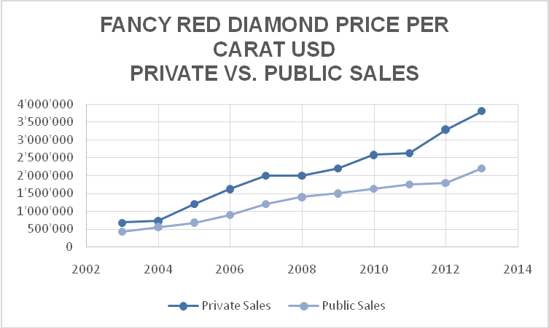
“Jewellery is a convertible asset. More and more people are looking at jewels for the value they represent over and above artistic… qualities. There are more people chasing the finer pieces. And this has added a premium to the signed jewels and they are harder to find…. One-of-a-kind jewellery with important stones is always desirable, but those pieces are in short supply.”
This was amply demonstrated over two consecutive days at auctions by rival houses Sotheby’s and Christie’s in Geneva, Switzerland, where coloured stones smashed several world records. On November 13, the 59.6-carat ‘Pink Star’ sold at Sotheby’s auction for US$83.2million; the predicted price was US$60million. The ring-mounted Pink Star is the largest flawless pink diamond that the Gemological Institute of America has ever graded.
On November 14 the world’s largest vivid-orange diamond, a 14.82-carat gem about the size of a finger-tip, broke two world records when it sold at the Christie’s auction, fetching the highest price per carat for any diamond sold at auction, as well as the highest price for an orange diamond. It is classified as ‘fancy vivid’.
Despite the evident role of auction-houses in provoking competitive bidding for rare stones, they are only one of the vendors operating in this market. Those sales which do not reach the headlines operate in private circles within a tight network of interested parties. Introductions lead to negotiations, which lead to further negotiations. It has been consistently proven that these exclusive personal connections are a higher guarantee of added value than sales in the public forum.
Devanx’s transaction fee of 3-5% covers these soft skills, as well as the cost of physical storage and handling fees. Taxation outlays are optimised by transacting in Zurich duty free zones, however transactions can also be made in Hong Kong and New York. The handling fees which range from 0.91-2% reflect the deal’s geographical location. Alternatively, the investor can choose to customize the handling process for their hard asset, and orchestrate a different investment jurisdiction. Whatever makes you feel most comfortable, we will do our best to accommodate.
Diamonds stored in the vault of DeVanx’s Custodian Bank UBS are highly secured. The Transaction Bank Malca Amit oversees processing and transport of the assets, and has considerable experience in this vocation. It has just finalised China’s largest privately owned state-of-the-art secured storage facilities, details on which are naturally closely guarded. Armoured vehicles and tracking devices come as standard.

