Press Release – Motoring

‘So you’ve passed your driving test….what now?’ is a new book written by Judy Bartkowiak an NLP specialist working with children and young people for those who have just passed their driving test. It contains all you need to know about advanced driving skills to tackle
- Coping with distraction from passengers
- Driving while tired
- Night driving
- Motorway driving
- Coping with stressful driving situations
- Driving in unfamiliar places
- Managing road rage
It is a quick easy read with plenty of examples and exercises in a workbook format so you can apply it to your own personality and driver type (there’s a quiz to find out what sort of driver you are).
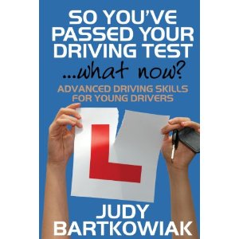
Driving represents freedom for young drivers and it is also the opportunity to learn new skills and apply these to your driving in different situations not covered by the driving test. What you think affects what you say and do. Neuro Linguistic Programming offers tools and techniques so that you can take control of how you think and drive safely and enjoyably.
Judy Bartkowiak is an NLP Master Practitioner and Trainer and can be contacted on 01628 660618 or email judy@nlpkids.com. Her website is www.nlpkids.co.uk

