PRESS RELEASE – BUSINESS PRESS
‘Secrets of Success in Brand Licensing’ written by Judy Bartkowiak and Andrew Levy (MX Publishing) was launched at the Brand Licensing Show in October 2011. It offers a unique guide to the world of Brand Licensing covering the role of the Licensing Agent, Licensee, Licensor and Retailer, giving insights from successful licensors in the fields of entertainment, publishing, design, celebrity, sport and toys such as Peppa Pig, Moshi Monsters, Where’s Wally?, Smiley, Thomas and Friends, Hello Kitty, Walker Books and many more.

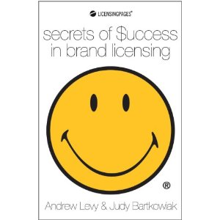
Judy Bartkowiak and Andrew Levy have worked in Brand Licensing guiding brands through the licensing process for 20+ years and share their own knowledge and experience as well as that of successful brands we see all around us today.
What is a Brand? Bartkowiak suggests that “What makes a product a brand is the acknowledgement and awareness of a promise made between the manufacturer and the consumer that this product is in some way unique in terms of its quality, performance, service or style in a way that is important and relevant to consumers in that product category. This promise is an emotional connection which makes the product a brand.”
Once a brand is strong; commanding a premium at retail, holding its price against competitive discounting and stands for values that are consistently held across global markets, it can extend into other categories from a solid customer base and reputation. By extending the brand, brand owners can establish themselves in new markets, new categories and attract new customers increasing awareness of the brand, consumer connection and a premium price leading to greater profits.
Secrets of Success in Brand Licensing contains chapters on Market Research, Sponsorship, Market Segmentation and the Marketing mix, Sales Promotion, PR, Social Media, Trade Shows and an all important section on the Legal and Financial aspects of Brand Licensing contributed by experts in their field.
Long gone is the time when Brand Owners could slap their brand logo onto just about anything, add a premium price and expect it to sell. There are hundreds of brands out there competing for shelf space and reduced consumer spend so the process of Licensing your brand has become more sophisticated and demanding of Brand Owners. This book provides unique insight into what retailers want today and how licensees need to respond.
Judy Bartkowiak can be contacted on 01628 660618 and via her website www.kids-brands.com

